**AWS Security Specialty Notes**

Reinvent videos

* [KMS](https://www.youtube.com/watch?v=hxWvbNvj2lg)
* [IAM](https://www.youtube.com/watch?v=YQsK4MtsELU)
* [CloudTrail 2020](https://www.youtube.com/watch?v=Tr78kq-Oa70)
* [Threat mgmt in the cloud with GuardDuty and Security Hub 2019](https://www.youtube.com/watch?v=vhYsm5gq9jE)
* [GuardDuty and Security Hub to secure multiple accounts 2020](https://www.youtube.com/watch?v=Rg2ZzAAi1nY)
* [Protecting sensitive data with Macie and GuardDuty 2020](https://www.youtube.com/watch?v=h7pq95RMuEQ)
* [Security investigations with Detective 2020](https://www.youtube.com/watch?v=itayQBdZRDo)
* [Systems Manager Automation 2020](https://www.youtube.com/watch?v=AaI2xkW85yE)
* [Systems Manager Deep Dive 2017](https://www.youtube.com/watch?v=BmpxZsk9N48)
* [Security best practices 2020](https://www.youtube.com/watch?v=wfIVI-M7lbQ)

[Knowledge Center](https://aws.amazon.com/premiumsupport/knowledge-center/)

Tutorial Dojos course and practice exams

Study Guide links and Common Exam Scenarios near beginning of eBook, Cheat Sheet at end of eBook

Pull slides from SysOps course for specific services

<https://media.datacumulus.com/aws-soa/AWS%20Certified%20SysOps%20Slides%20v2.3.pdf>

**Domain 1: Incident Response**

**Config**

* Helps w/auditing config and compliance of resources
* Per region; can be aggregated across regions/accounts
* Delivers info to S3 bucket; can get notifications from SNS topic
* can send details to CW Events which can be configured to invoke a Lambda to restore/fix resource config
* Rules: AWS Managed (security group SSH access, account password reqs for policy for IAM users, EBS volumes encrypted, ALB config, S3 bucket public access) and Custom (use Lambdas built by customer)
* Scenario: create Config rule to flag VPC if Flow Logs are disabled, Lambda to enable them, CW Event rule based on Config event to trigger Lambda
* Ensure only approved AMIs used to launch EC2 instances – **approve-amis-by-id** managed rule in Config

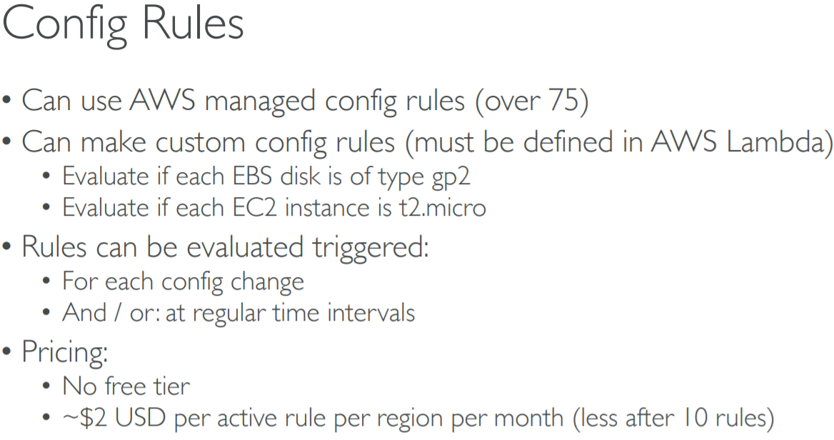 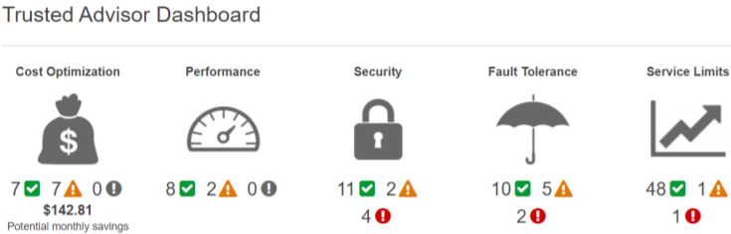

**Trusted Advisor**

* Unlike Config users can NOT specify resources to be assessed – but can ALSO use CW Events + Lambda
* Detection for MFA on Root Account, S3 buckets w/open access permissions, security group rules allow unrestricted access
* No need to install anything; all customers get core checks/recommendations account assessment
* Can enable weekly email notification from console

**CloudTrail**

* Event history - view activities ie **access key** used, username, date of occurrence and affected resource
* IAM Console – you can delete or disable access keys

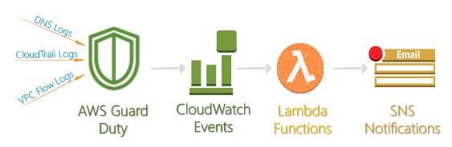

**GuardDuty**

* Regional; intelligent threat detection for malicious/suspicious behaviors reported to Console
* Integration with CW Events, Lambda
* Suppression rule – filters new findings that match the filter criteria defined in rule
* Trusted IP lists – whitelisted; GD does not generate reports against activities originating from Trusted IPs
* Threat lists – known malicious IPs

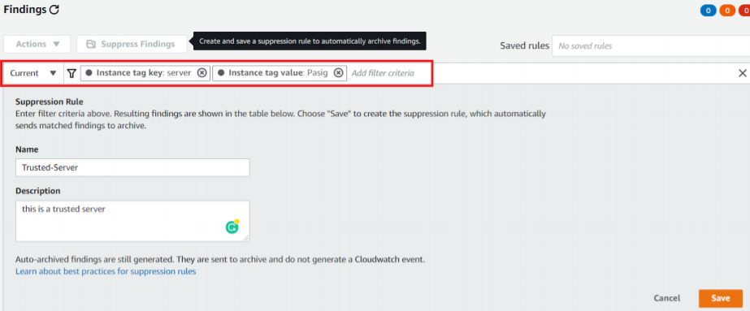 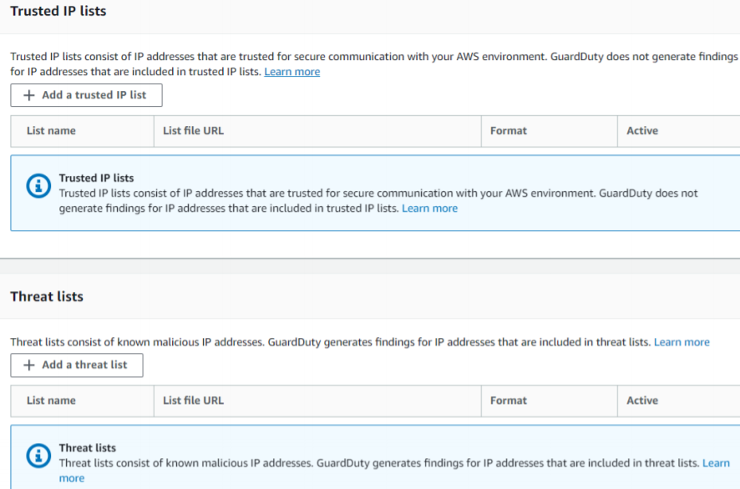

* Data sources:

1. VPC Flow Logs (do NOT need to turn on) – network traffic on ENIs
2. DNS logs – queries made from EC2 instances to known suspicious domains; does NOT work on 3rd party DNS resolvers
3. CloudTrail events

* Detect EC2 instances that connect to known Command and Control server – swarm of computers (botnets) that perform unified, repeated harmful actions

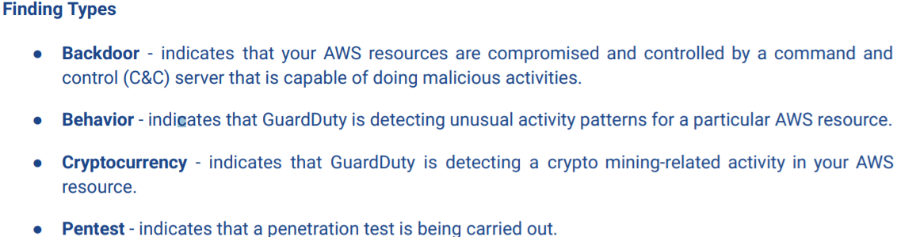 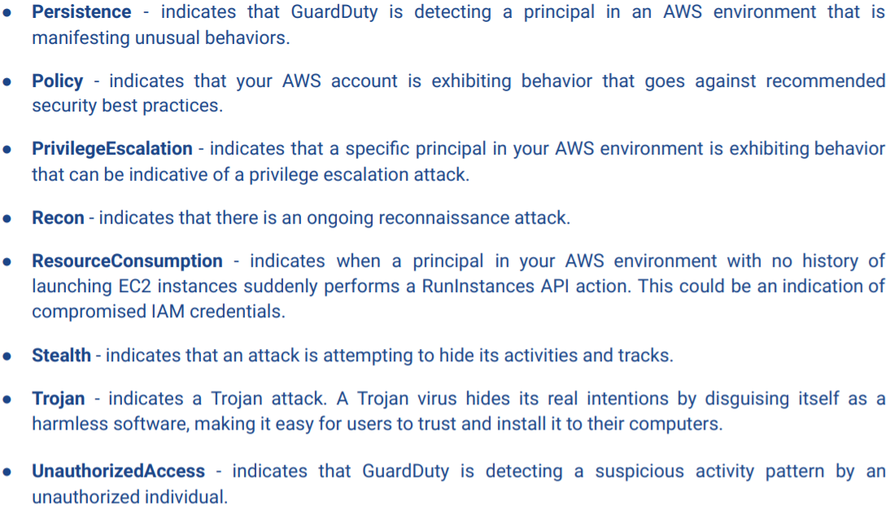

**Personal Health Dashboard**

* Gives alerts/remediation when AWS is experiencing events that can impact your resources’ performance
* Also integrates w/CW Events & SNS so we don’t have to periodically check the board

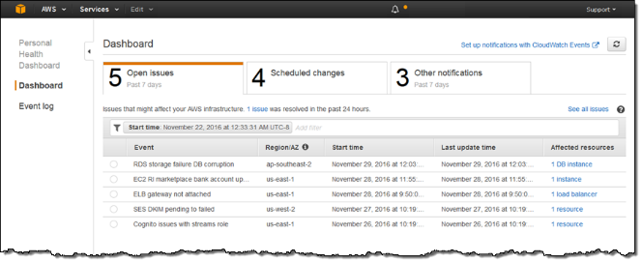 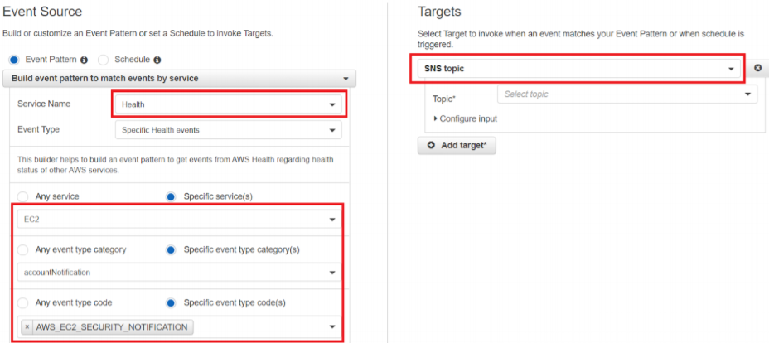

**EC2 Inspector**

* Uses service linked role; install Inspector Agent on EC2 instances that are included in the assessment target
* Execute an Assessment Run that uses an Assessment Template with Rules to discover security issues; the data collected is the Telemetry encrypted by KMS and stored in S3

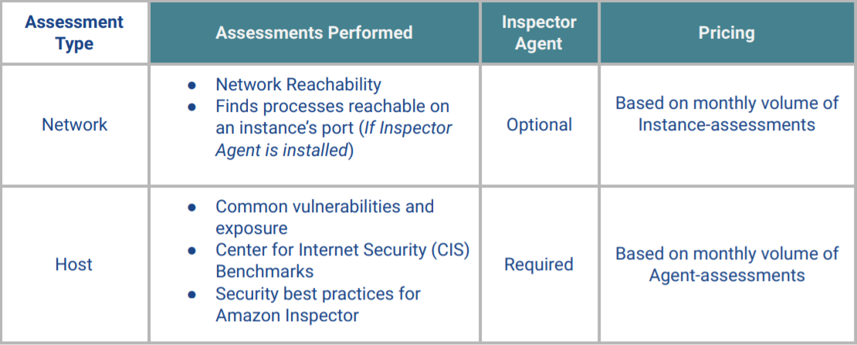 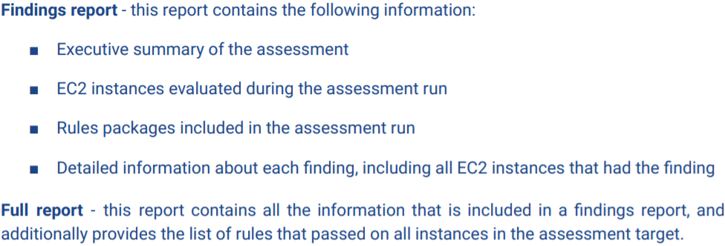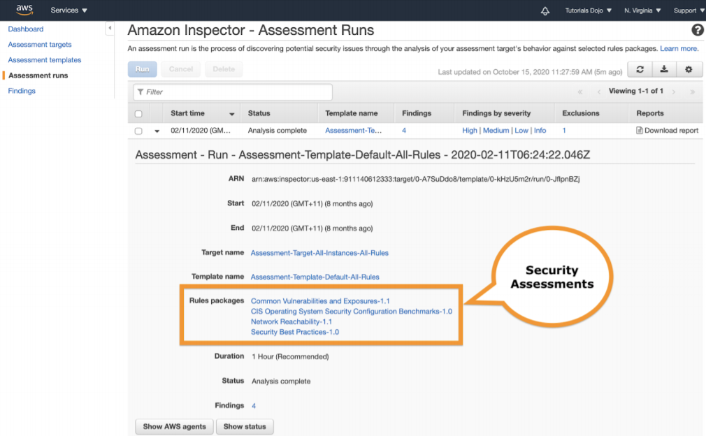

**Systems Manager – Patch Manager**

* EC2/on-prem; scan instances for missing patches and apply them individually or to Patch Groups; use Maintenance Window for recurring schedules
* Patch Groups – instances organized by tags
* Patch Baselines – define which patches are approved for installation; can create own baselines

**EC2 Instances w/compromised SSH Private Keys**

* Key pair - Public key encrypts data (stored in EC2 instance); private key decrypts (stored local computer)
* At boot time the public key is placed on your Linux instance in an entry w/in ~/.ssh/authorized_keys
* You can never recover private key once you lose it
* **Systems Manager Run Command** lets you remotely/securely manage instances’ config w/o opening an inbound port in your security group’s rule; does NOT require key pair when connecting – just associate IAM role giving SSM permission to perform actions on your instances

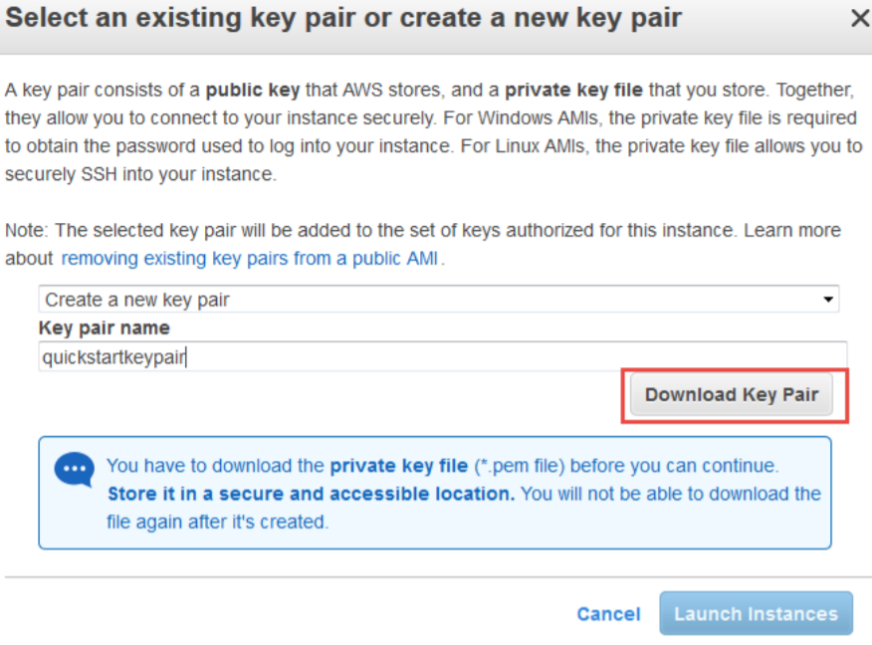

**Artifact**

* Reports – ISO, SOC and PCI reports and certifications from 3rd party auditors
* Agreements – Account and Organizations agreements (only master account in org can accept agreements)

**Abuse**

* Sends reports to customers about potentially abusive activities
* Ie: spam, port scanning, DDoS, intrusion attempts, objectionable/copyrighted content, distribute malware

**Domain 2: Logging and Monitoring**

**CloudWatch**

1. Metrics – create custom dashboards; all dashboards are GLOBAL – not region specific
2. Events – events that describe changes to resources; Rules match incoming events and routes them to Targets for processing
3. Logs – default: kept indefinitely (EC2, CT, Route 53 logs); Insights – filters; Agent
4. Alarms

* There are no CW ARNs to use in an IAM policy; use * instead as resource when writing a policy to control access to CW actions

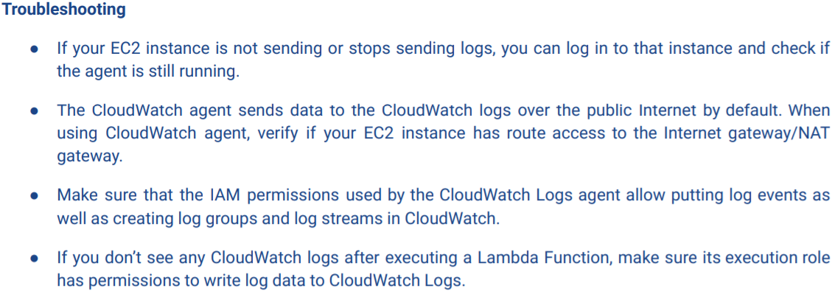

**CloudTrail**

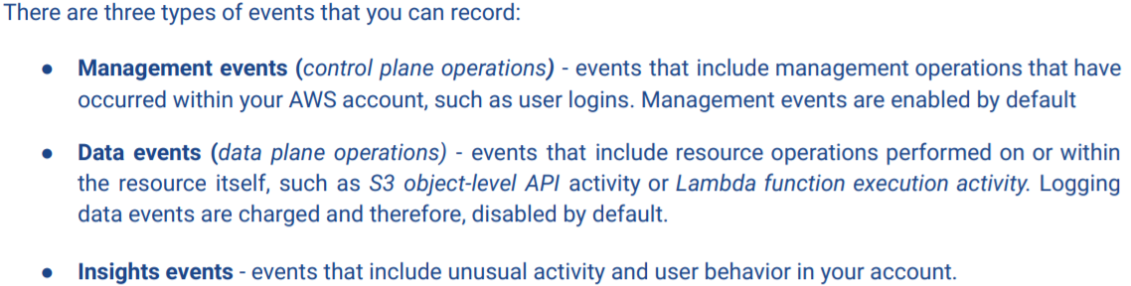

* Even w/o a trail you can still view history of API activities in your account with Event History past 90 days
* You can use event filter definitions to only view particular events in Event History

1. Read-only events – API operations that read resources ie: ListBuckets, DescribeMetricsFilters
2. Write-only events – API operations that modify or may modify ie: DeleteBucket, TerminateInstances

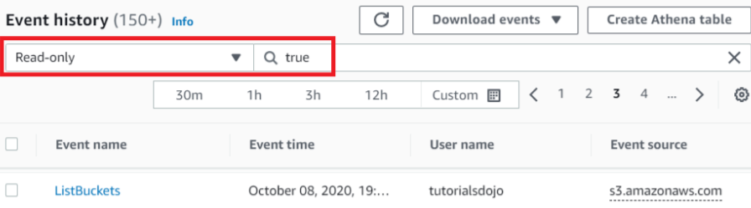 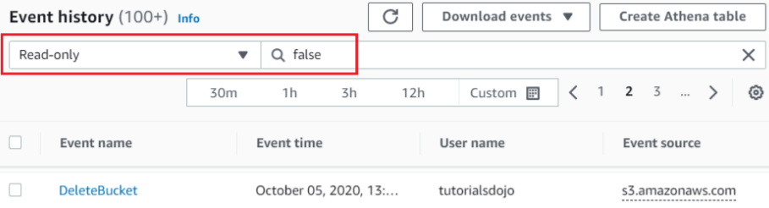

* CT sends logs to S3 bucket of your choice however you can configure a trail to send logs to CW Logs to monitor log data – and CW Logs can trigger alarms according to defined filters
* **Log File Validation** – protect authenticity of logs from data tamper using SHA-256 hashing/digital signing; enabled by default when you create a trail

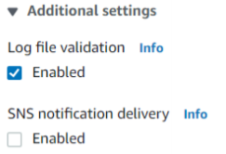 

* **Multi-Region Trail** – aggregate all log files from different regions into a single bucket (automatically enabled when you create trail in Console, but can also change existing single region to multi region by appending --is-multi-region-trail in update-trail command)
* **Multiple Accounts**

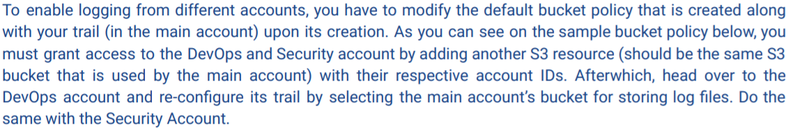

CW Logs Agent Troubleshooting

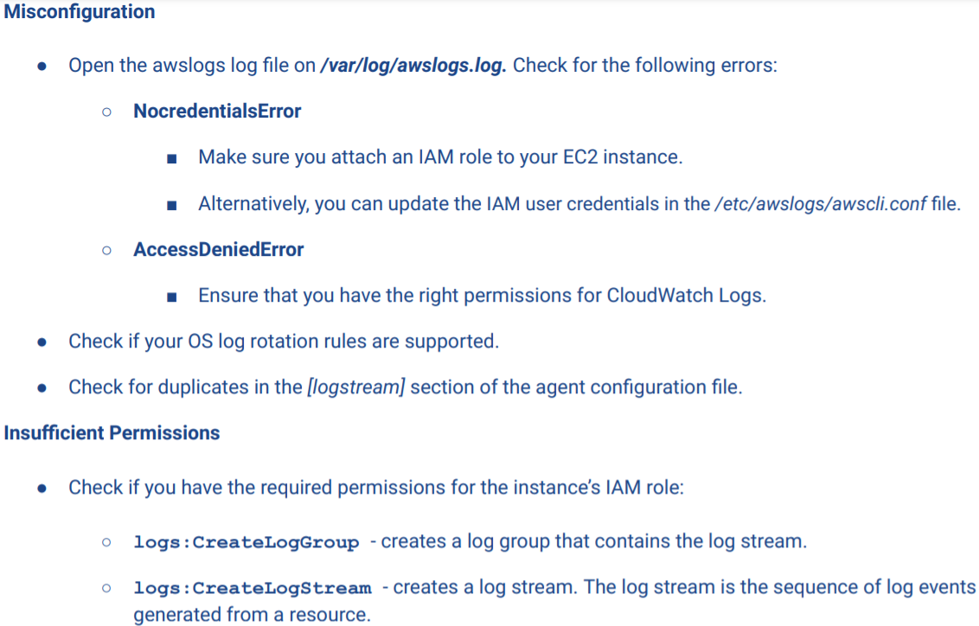 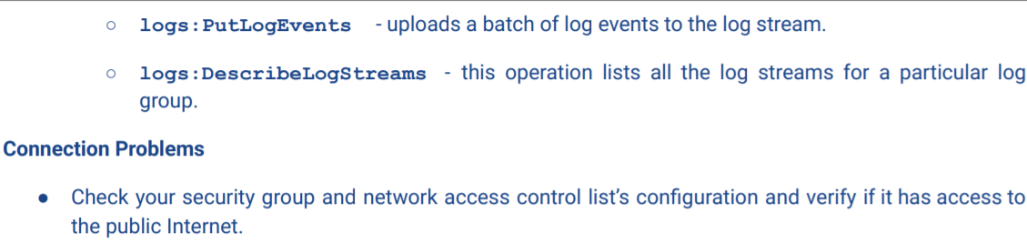

**Central Log Collection using CW Logs**

* Log Groups & Log Streams to compartmentalize log files; default never expire but can change 24 hrs-10yrs

**Unified CW Agent**

* Awslogs agent –old version; Unified agent – new
* On prem must have server use an IAM user w/programmatic access (key/secret) w/correct permissions
* Can retrieve custom metrics from apps using StatsD and collectd protocols
* You need to have permission to use cloudwatch:putMetricData

Streaming Logs – no need for ‘tail –f’ command; view streaming of log events on CW Logs Dashboard

Log Rotation

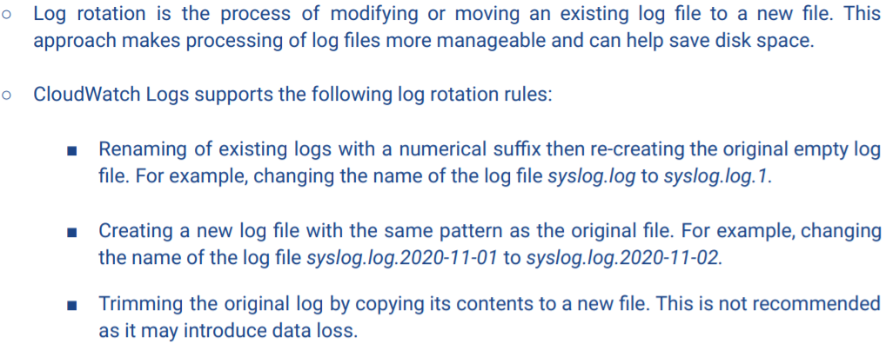

CT delivers trail logs to S3 by default, but we can optionally configure CW Logs to monitor our trail logs so we can create an alarm when a certain activity happens (create CW Metric filter)

1. Too many unauthorized attempts:

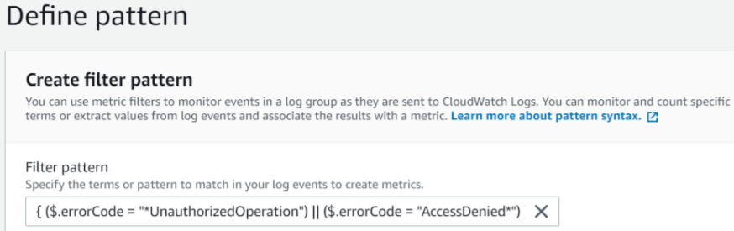 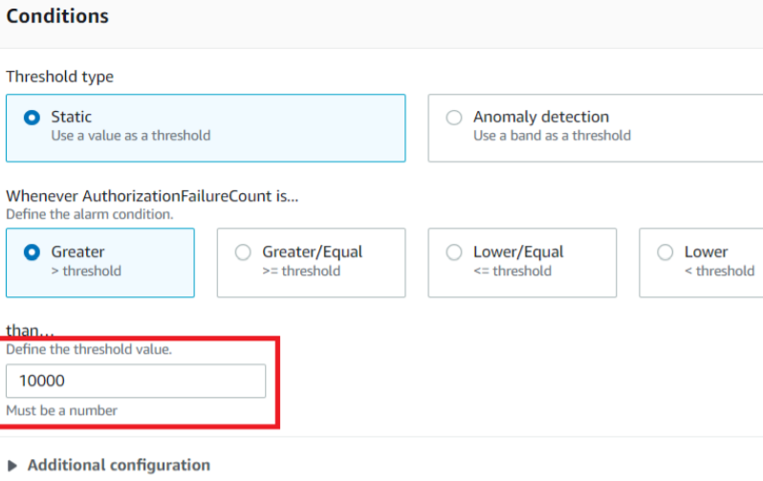

1. Monitor Security Groups frequently updated

(Create/Delete)SecurityGroup, AuthorizeSecurityGroup(E/In)gress, RevokeSecurityGroup(E/In)gress

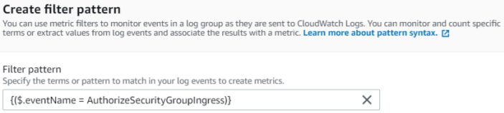 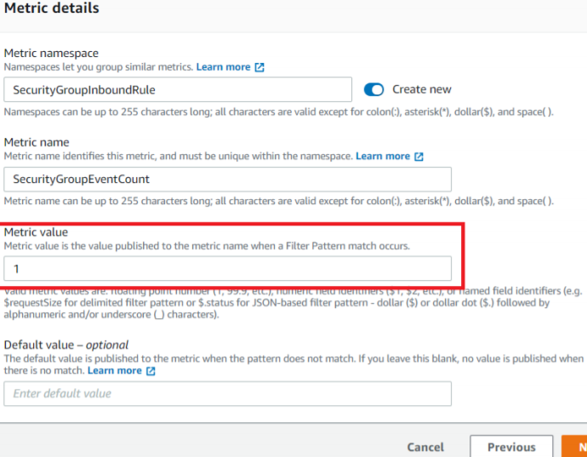

**Monitoring root account** activities using **RootAccountUsage** filter

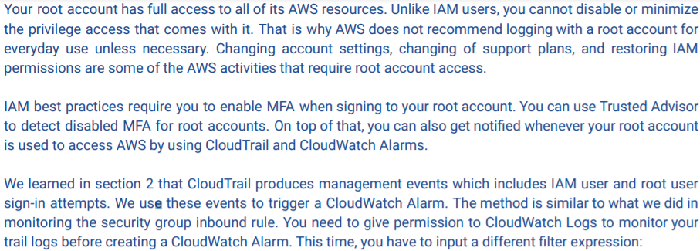



**CloudWatch Managed Policies**

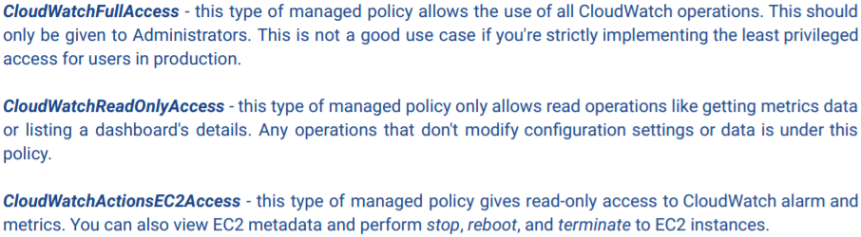

**Real-time logging using Kinesis Firehose and Elasticsearch**

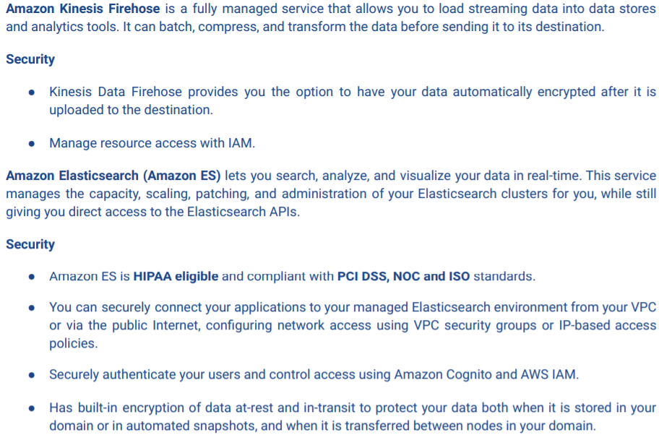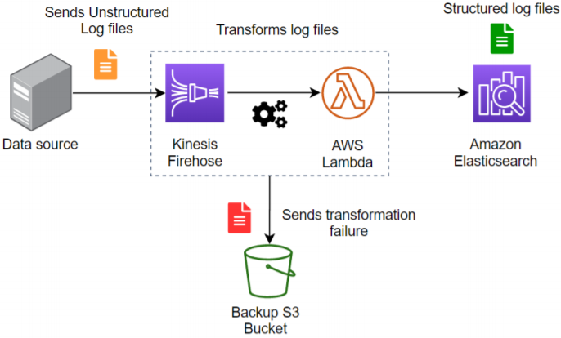

**Domain 3: Infrastructure Security**

**KMS**

* Integrated w/CT; choice to have KMS automatically rotate master keys once/yr
* **Customer Master Keys** encrypt/decrypt up to 4KB of data; typically used to generate, encrypt and decrypt the data keys that you use outside of KMS to encrypt your data
* **Customer Managed CMKs** are CMKs you create, own and manage; full control over these CMKs
* **AWS Managed CMKs** are CMKs in your account; can NOT manage, change permissions or use in cryptographic operations directly – service creates and uses them on your behalf
* **AWS Owned CMKs** – not in AWS account; part of a collection of CMKs that AWS owns and manages for use in multiple accounts; can NOT view, manage, use or audit their use
* **Data Keys** – encryption keys that you can use to encrypt data
* **Encryption Context** - optional set of key-value pairs that can contain additional context info about data
* **Key Policies** – document of permissions that determine who can use and manage the CMK

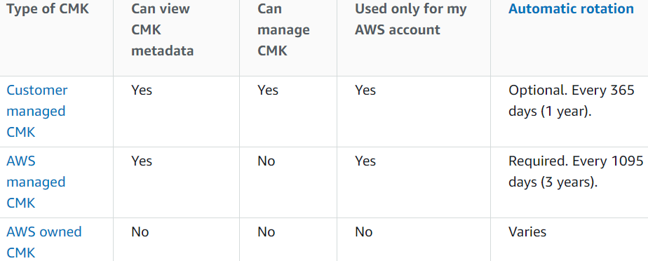 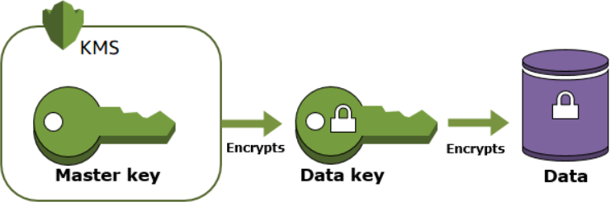

**Envelope Encryption** – using CMK to encrypt data key that encrypts data

**Alias** – key ID is alphanumeric string; alias is easier

 

To migrate an encrypted resource (EBS/RDS snapshot) to another region you have to create a new CMK in that destination region or use AWS managed keys for that particular service

**Importing Keys**

* A CMK contains the **key material** used to en/decrypt data. When you create a CMK, by default KMS generates key material for that CMK but you can create a CMK w/o key material and import your own.
* When you import key material you can specify an expiration date. When the key material expires, KMS deletes the key material and CMK becomes unusable. You can also delete key material on demand.

**Deleting Keys**

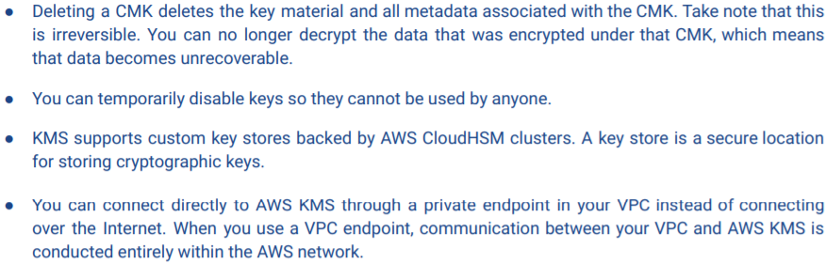

**API Commands**



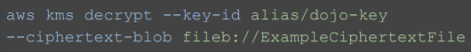

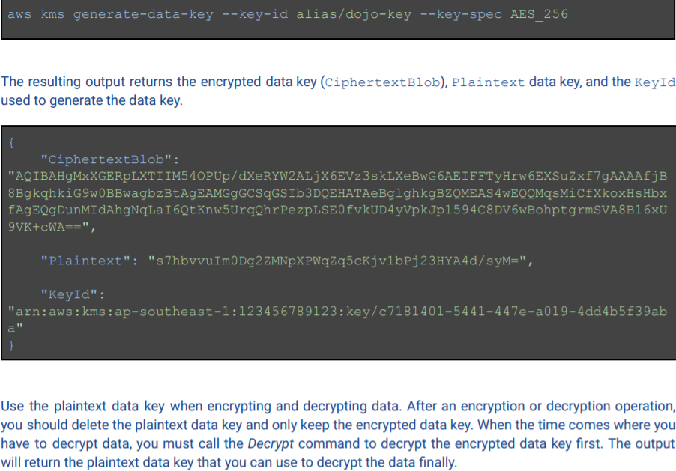 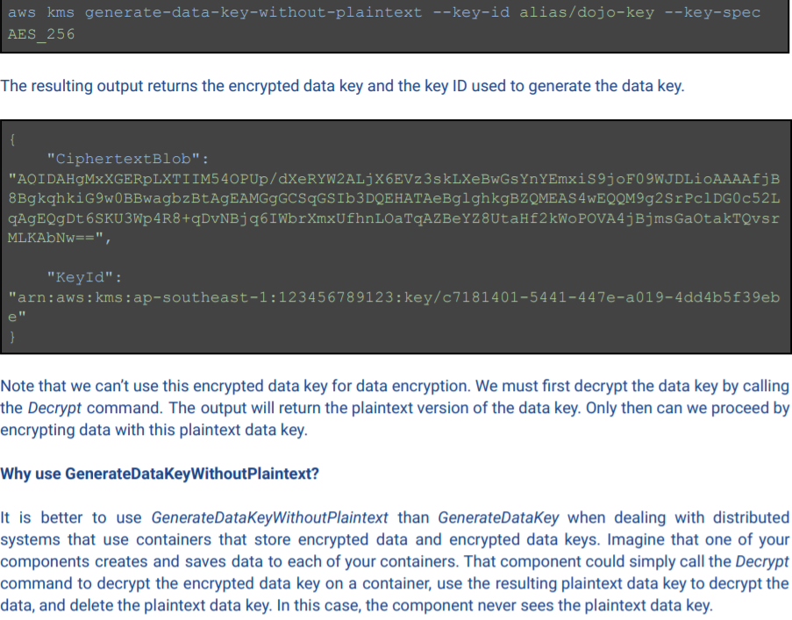

**Key Policy**

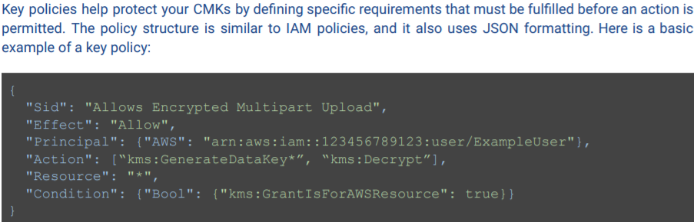 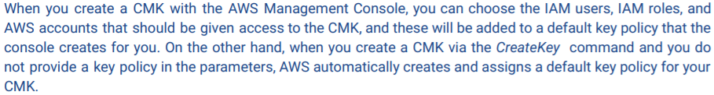

* The default policy gives access to all IAM entities in the AWS account for the CMK

**kms:ViaService Condition Key**

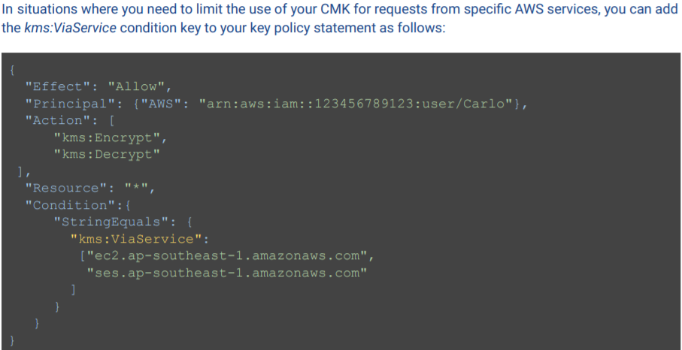

**Grants**

* Only one key policy for each CMK

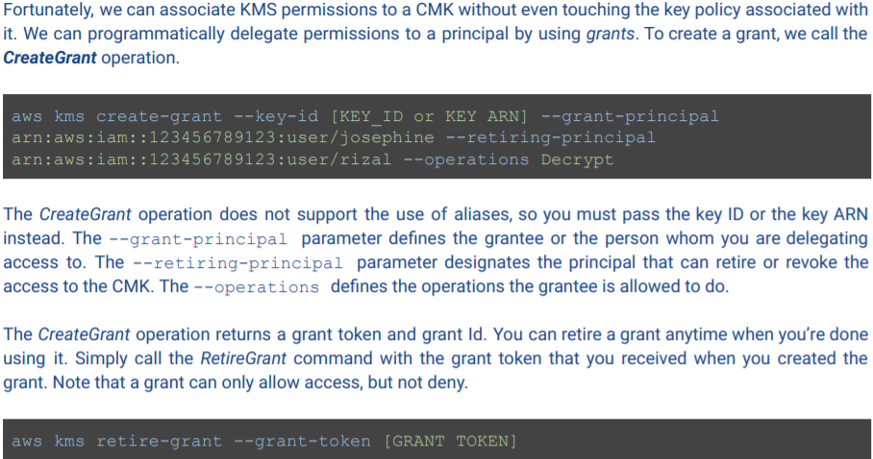

**KMS CMK Rotation**

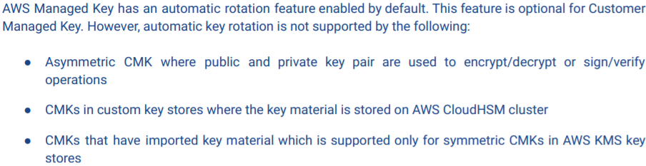

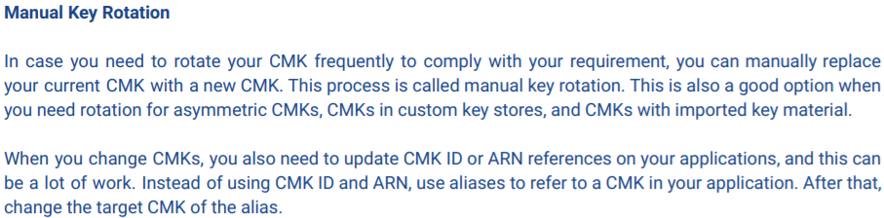

* When automatic key rotation is enabled the properties of the CMK do not change – only the backing key – a cryptographic material that is used in encryption operations
* AWS Managed CMKs are rotated every 3 years and can NOT be managed
* Customer Managed CMKs allow you to optionally rotate annually
* Once a CMK is renewed whether it’s AWS or customer managed, it writes a KMS CMK Rotation event on CW Events and RotateKey event on CloudTrail

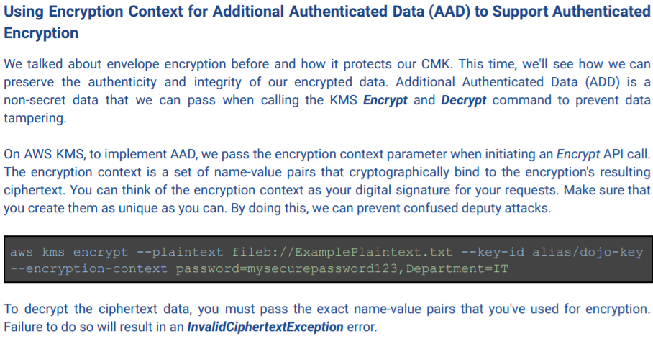

**HSM**

* expensive, dedicated, tamper-resistant device that performs en/decryption and can store encryption keys; comes in form of PCI, rackmount device or USB

**AWS CloudHSM**

* exclusive, single-tenant access; full control over keys and life cycle
* must use CloudHSM Client – software package to communicate to CloudHSM
* highly available, only accessible by using VPC (and Client on EC2 instance inside VPC), tamper-resistant, access logging on EC2 instance with Client and API calls on CT

**WAF**

* protect web apps from attacks with rules to allow/block/monitor requests based on defined conditions
* conditions filter requests based on IP addresses, HTTP headers/body or URI strings to block SQL injections or cross-site scripting

Rules:

1. Custom

* Regular – use only conditions to target specific requests
* Rate – count requests that arrive from an IP address every 5 min; can trigger an action if the number of requests exceeds the rate limit

1. Managed – deploy pre-configured rules to protect apps from common vulnerabilities

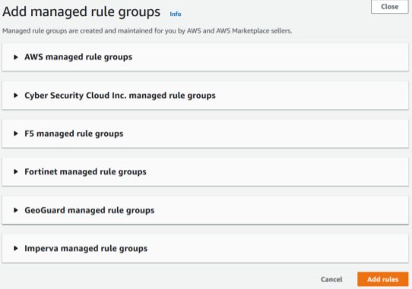

**Firewall Manager**

* Simplify WAF admin tasks across multiple accounts/resources; use w/Organizations
* Define policy rules and scope; resource types include API Gateway and ALB

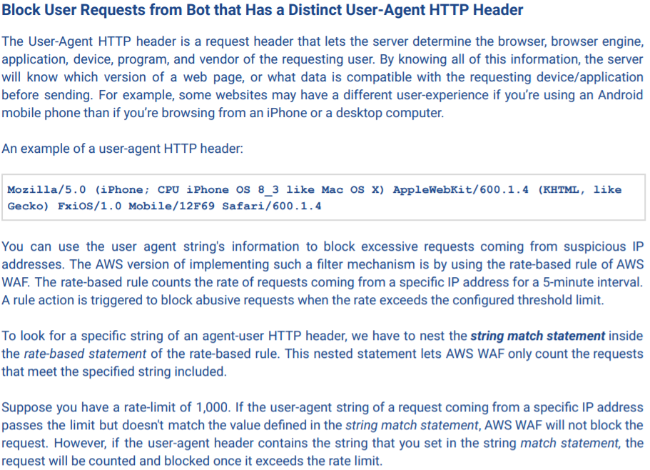

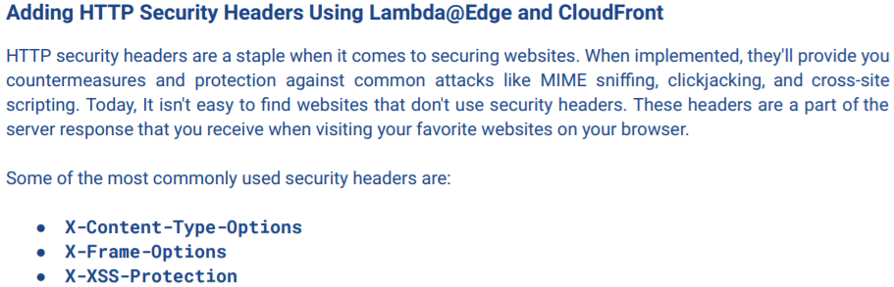 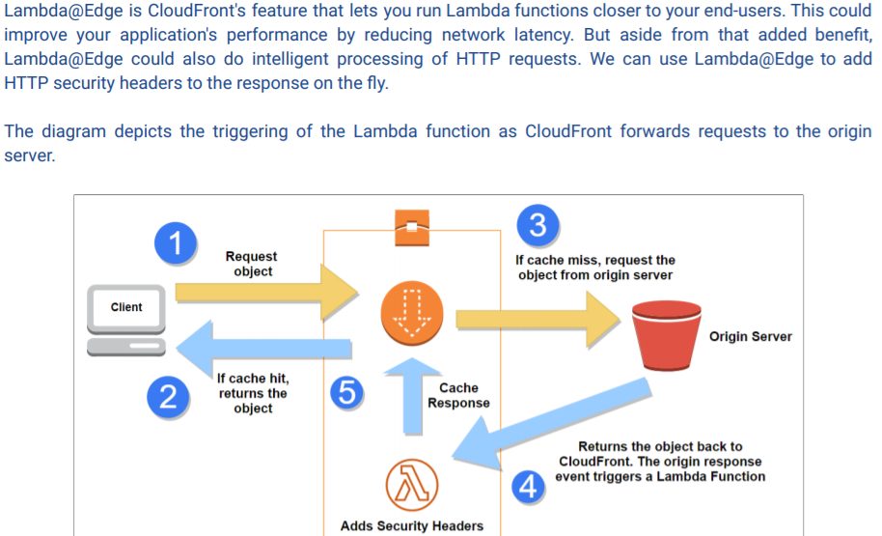

**CloudFront**

* Restrict access to S3 files: Signed URL and Signed Cookies (CloudFront-<Expires, Signature, Key-Pair-Id>)
* S3 endpoint and Cloudfront endpoint
* OIA – prevents users from bypassing Cloudfront endpoint, Signed url/cookies and directly accessing S3

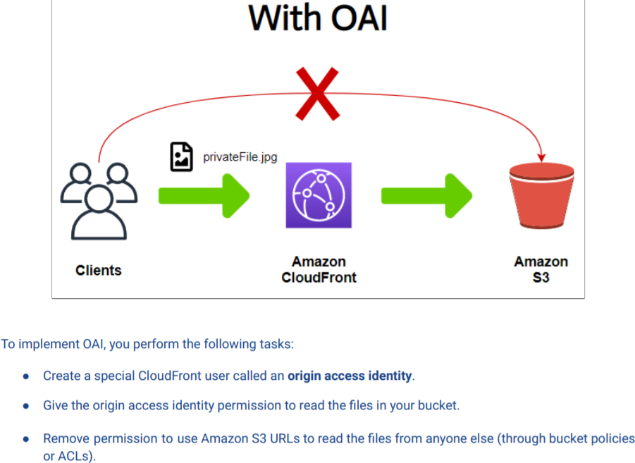 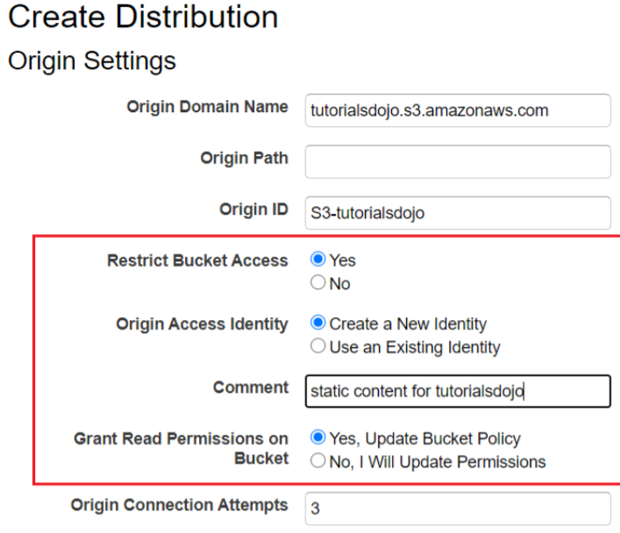

**S3 Multi-part upload**

* aws s3 cp; CMK has 4KB limit – must use envelope encryption for larger files; SSE-KMS automatically handles envelope encryption as long as you have permissions on the KMS key

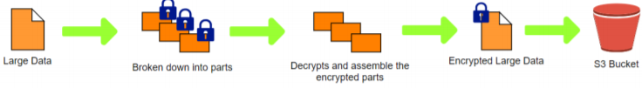

**AWS Shield to protect from DDoS attacks**

* Standard – inspects incoming traffic and detects malicious traffic in real time
* Advanced – enhanced detection, inspects network flows and monitors app layer traffic to elastic IP, ELB, CF or Route 53

DDoS Attacks

1. Infrastructure Layer (3 & 4) – large volume of packets/requests; smurf attacks, SYN and UDP floods
2. Application Layer (6 & 7) – small volume; flooding of HTTP requests or search API & WordPress pingbacks

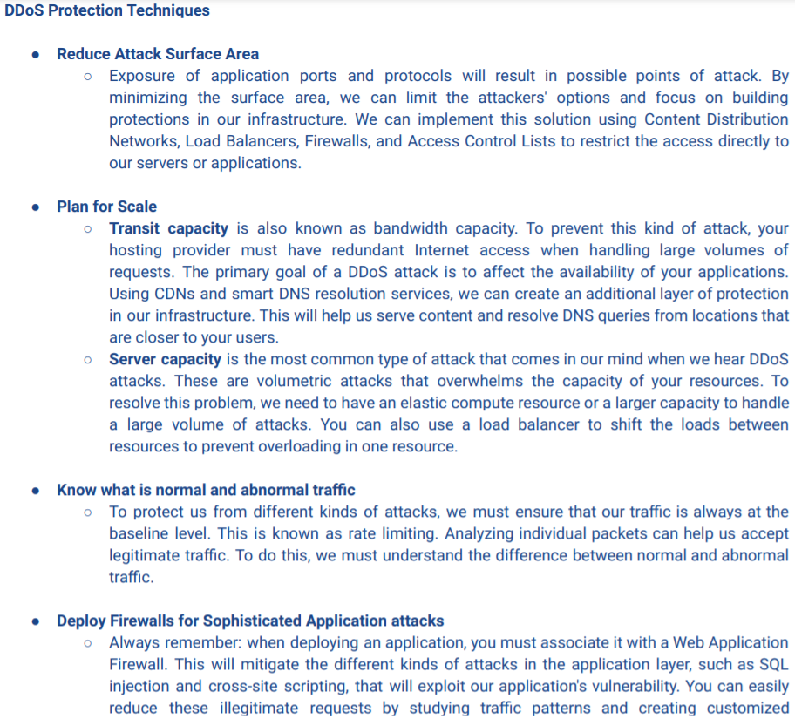

**Integrating AWS resources that are possibly compromised**

**Security Hub**

* View of your security state w/in AWS and compliance w/security industry standards and best practices
* Dashboards that consolidate your security across accounts to show their security and compliance status
* All findings stored for at least 90 days

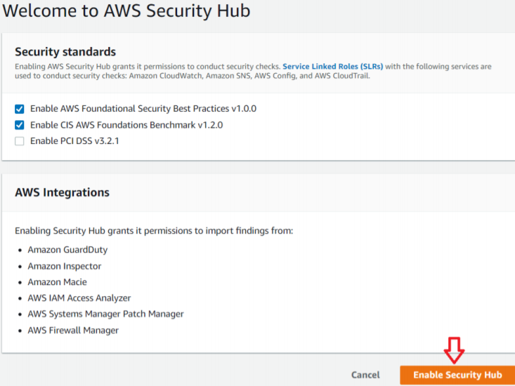 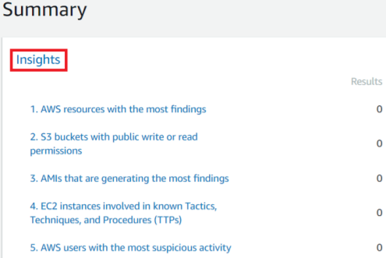

**Cognito**

* Web/mobile; authentication/authorization/user management; pre-built login UI; synchronization of data across devices/apps
* Identity Pools - unauthenticated guest access

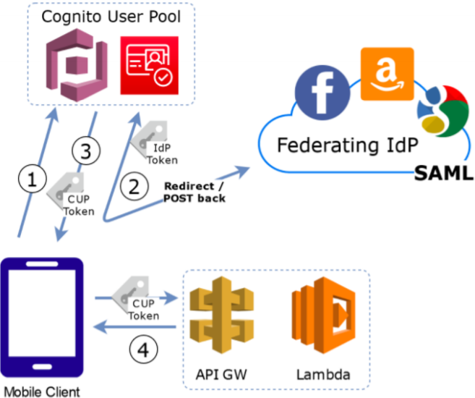 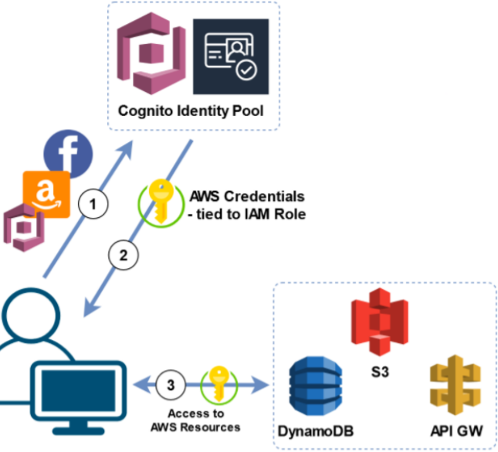

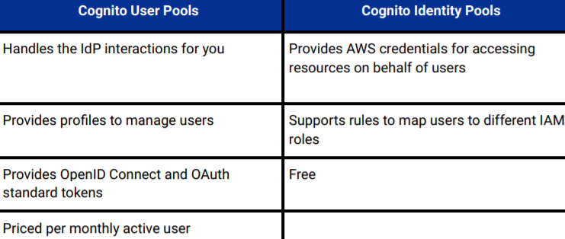 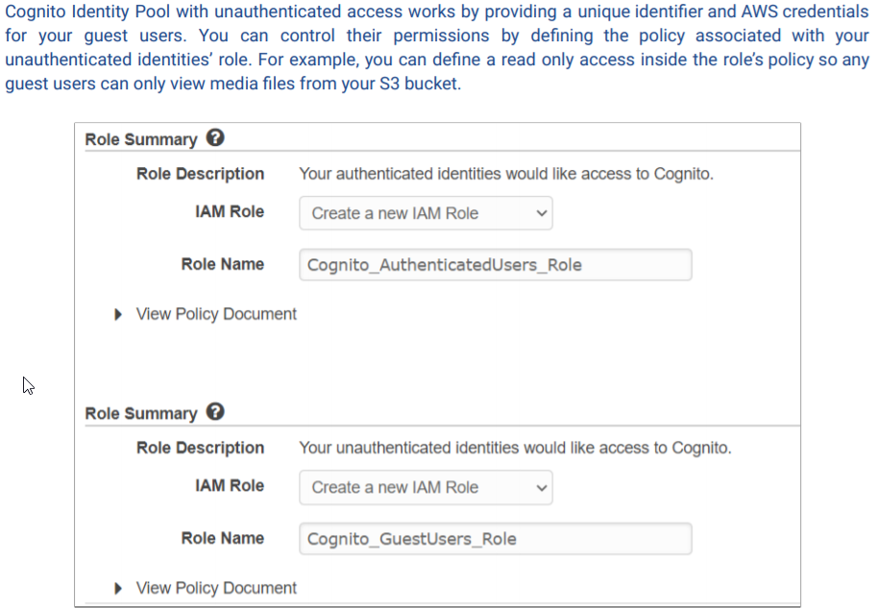

**EC2 Instance Profile** – container for IAM role to make API calls

**Switching IAM Roles and Access Keys from Config/Credentials files**

* You can set up different profiles in the config and credentials file. From the CLI you can switch b/t one profile at a time

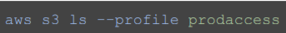 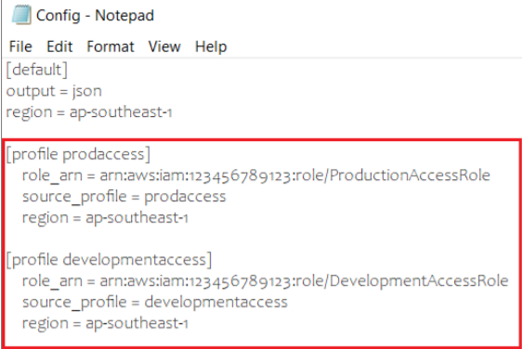 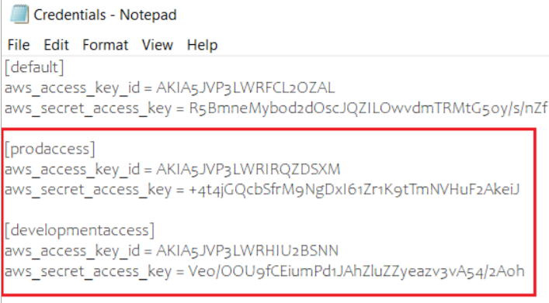

**Using VPN to encrypt connections to AWS resources in 4 ways**

1. Site to Site VPN

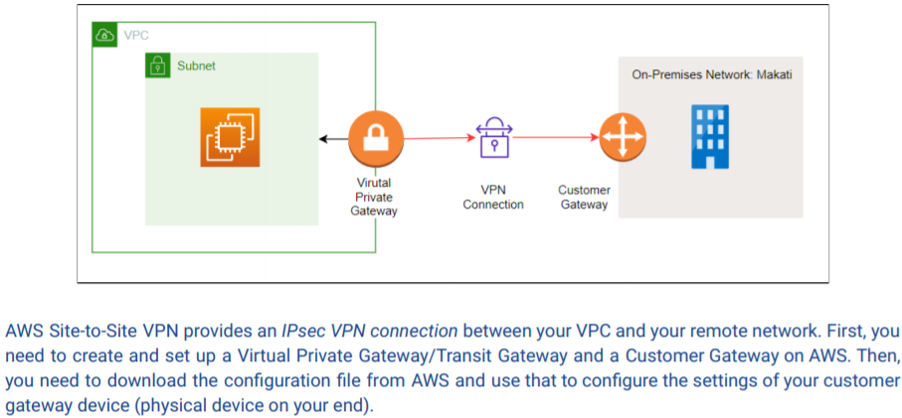

1. Client VPN

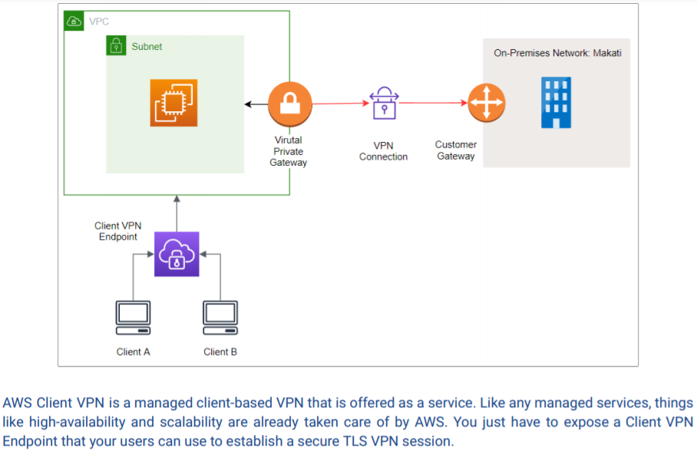

1. VPN CloudHub

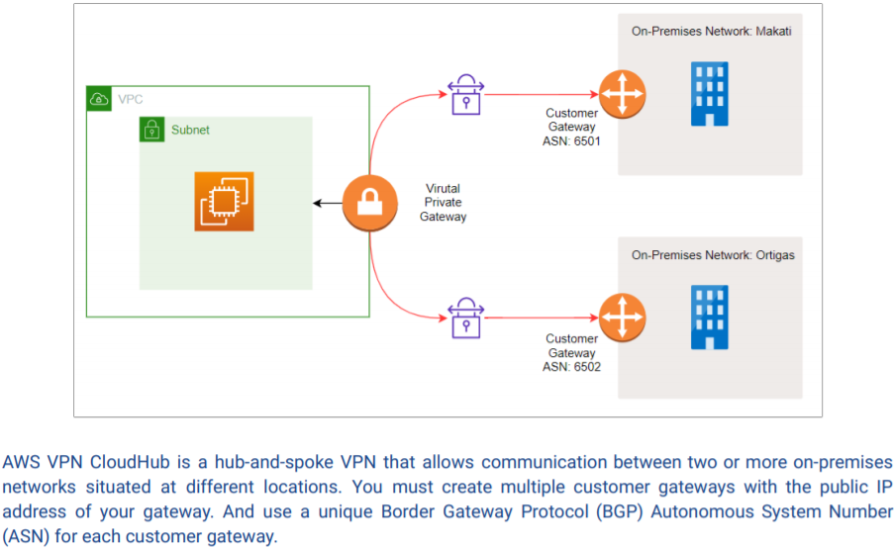

1. 3rd Party Software VPN Appliance

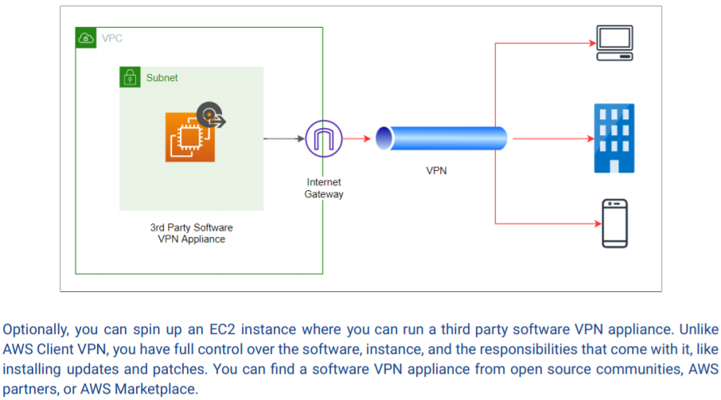

**Penetration Testing** – you do NOT have to submit a request form to conduct on permitted AWS resources

**Billing Permissions**

* AWS Organizations uses consolidated billing where the master account pays the bills and gets pricing benefits of aggregated usage such as volume discounts for EC2/S3
* A role can be created so that the child accounts can view only their billing info in the master account

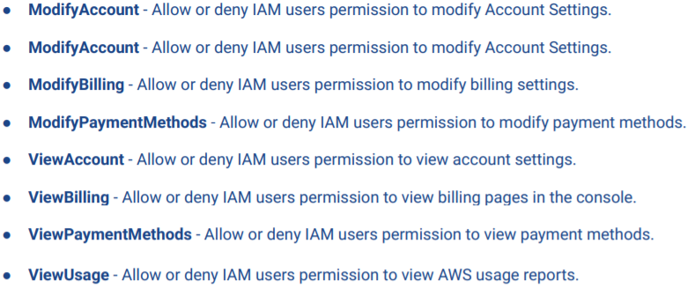 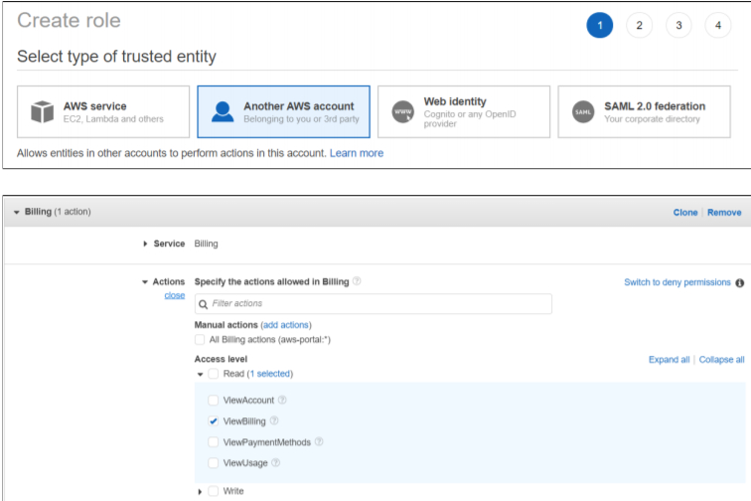

**Preventing staff from adding rules to security groups w/o approval**

* Example: Employee wants to add inbound access to SSH port from anywhere. Bad way to fix it is to use a NACL to filter out source IP matching 0.0.0.0/0 CIDR range. The right way to fix it is using a managed AWS Config rule – **vpc-sg-open-only-to-authorized-ports**.
* It checks whether the security group w/ 0.0.0.0/0 of any VPC allows only specific inbound TCP or UDP traffic. The rule is compliant if there is a security group w/inbound 0.0.0.0/0 with no ports provided in the parameters.

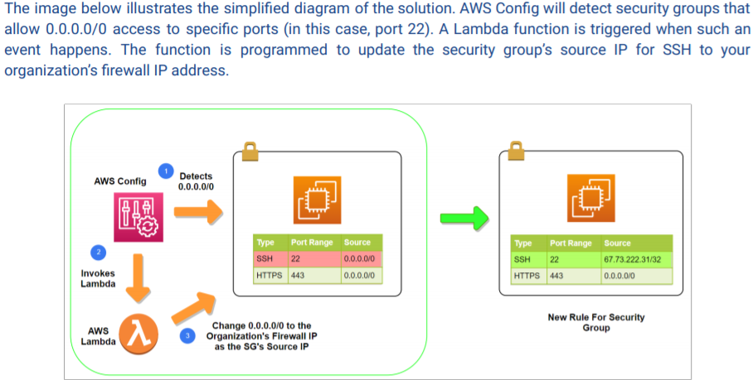

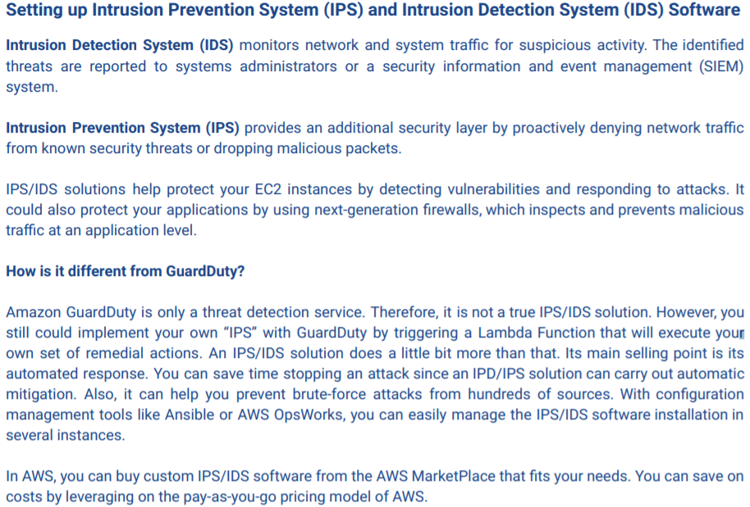

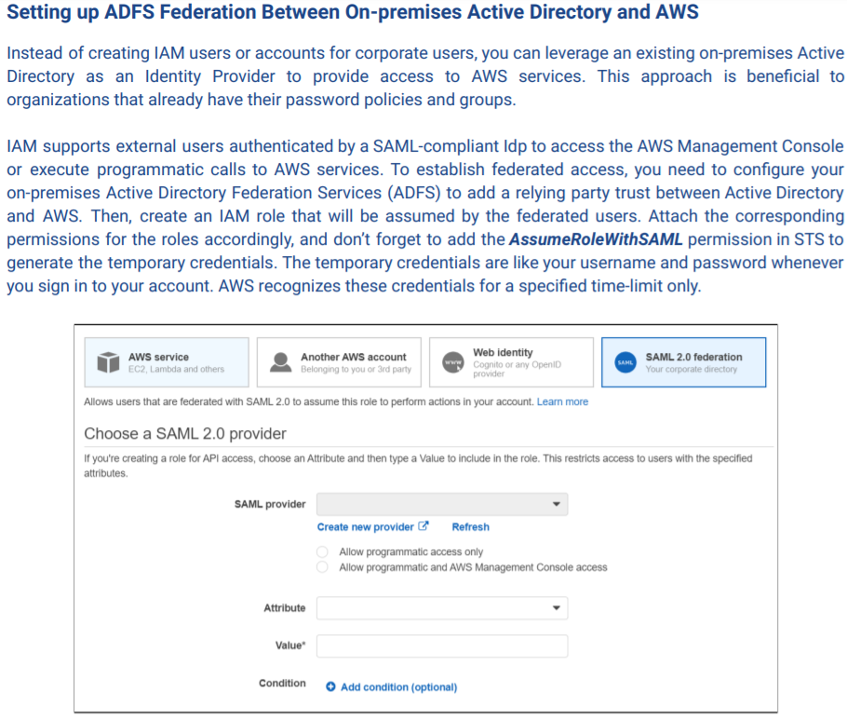 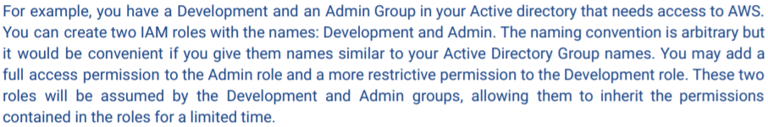

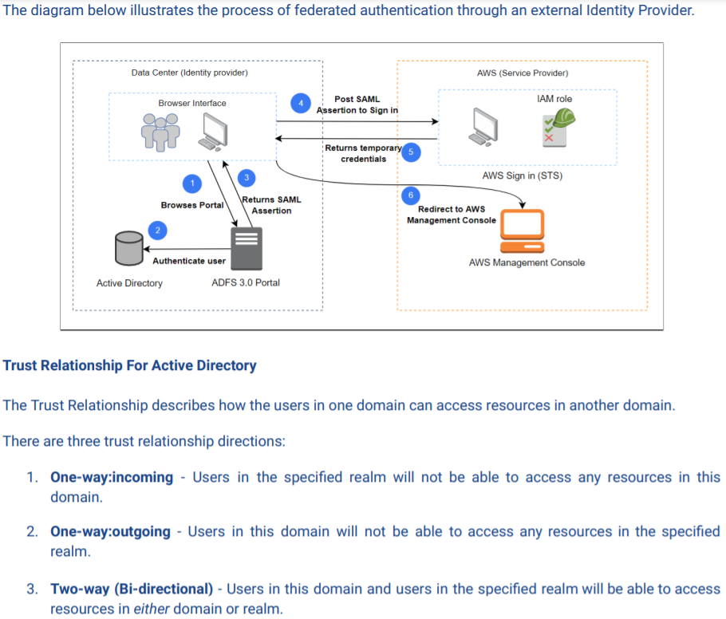

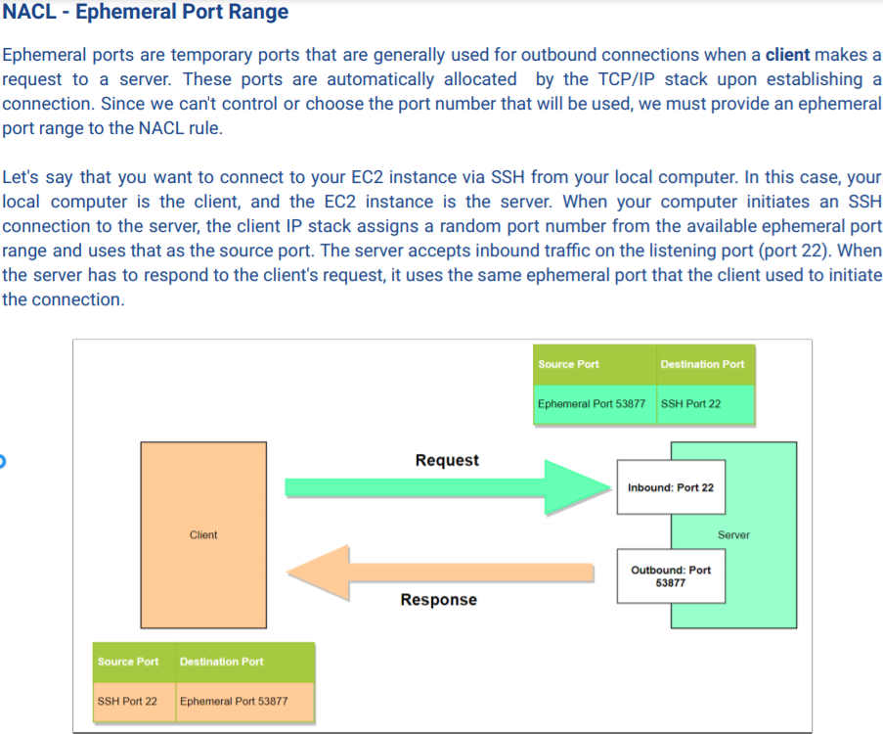

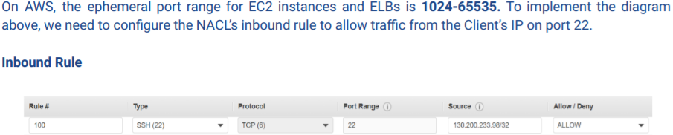

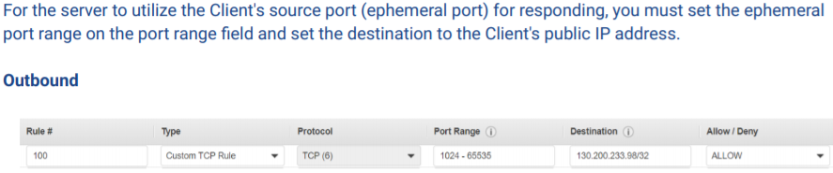

**Ways to reduce attack surface (ways to enter network) from cyber criminals**

1. Create security group that only allows specific ports and authorized servers
2. Set up NACLs that only allow required ports and network addresses in your network
3. Protect your origin server by putting it behind a CloudFront web distribution
4. Enable AWS Shield Advanced for enhanced DDoS attack detection and monitoring for app-layer traffic

**SSM and Secrets Manager**

* SSM – during parameter creation you specify the data type: String, StringList, SecureString
* SecureString uses either customer or AWS managed CMK; app sets WithDecryption to True

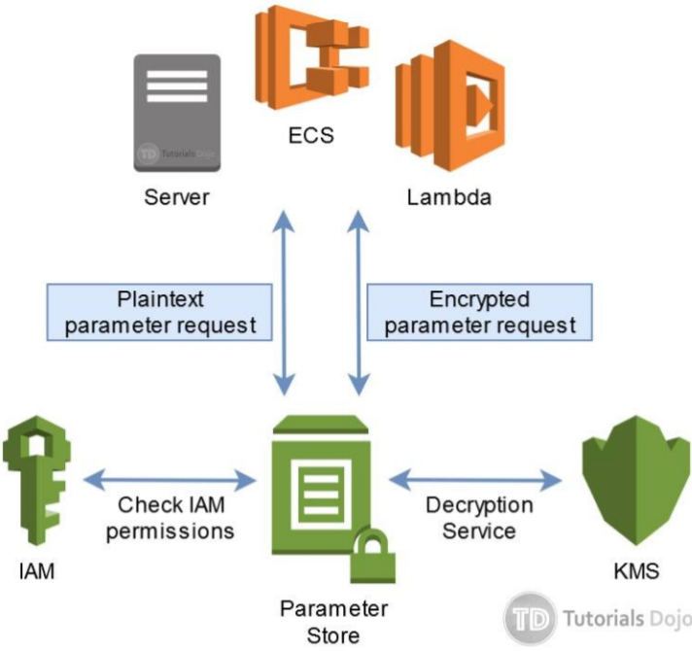 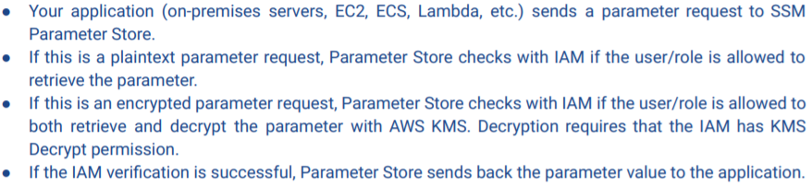

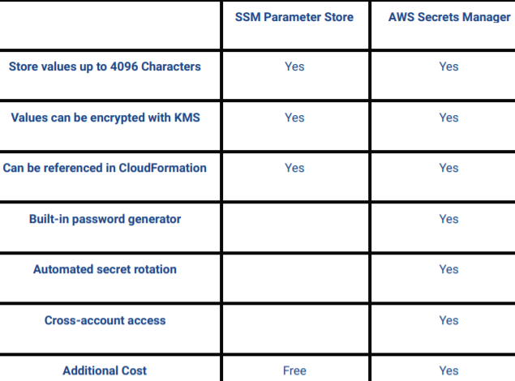

**VPC Flow Logs**

* Incoming and outgoing IP traffic of VPC; published to either **CW Logs or S3**

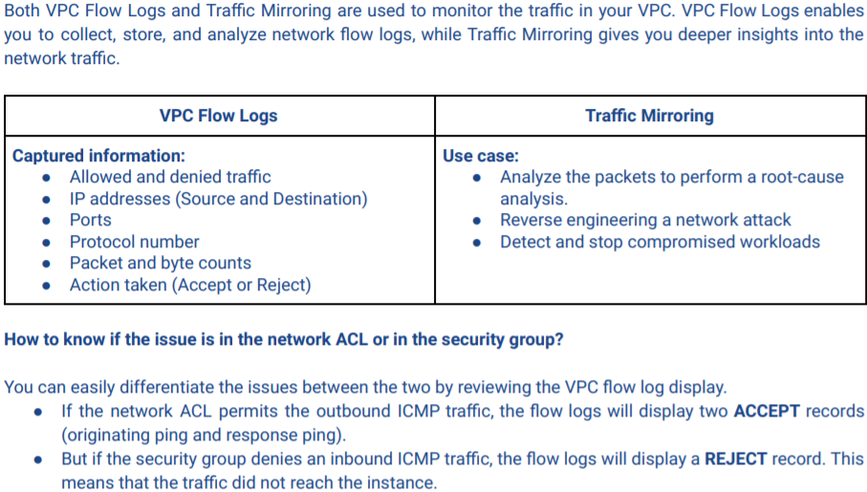

**GuardDuty Multi-account aggregation**

* GuardDuty findings from secondary accounts can be aggregated into a master account by sending invites
* Secondary accounts need to enable GuardDuty before accepting invite; master needs it enabled too

**Host Based Security**

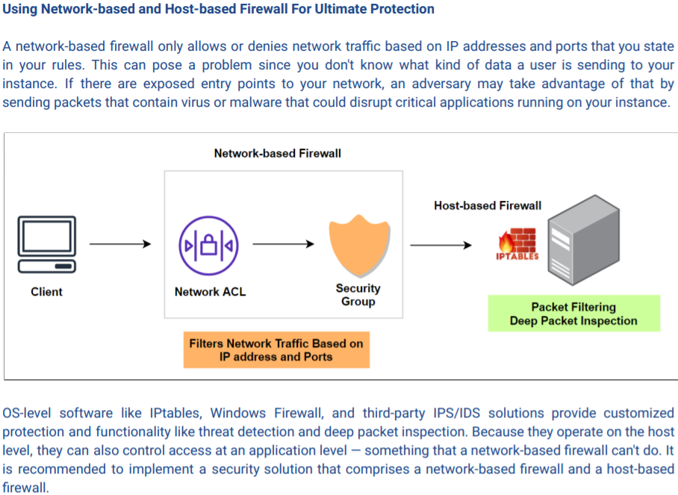 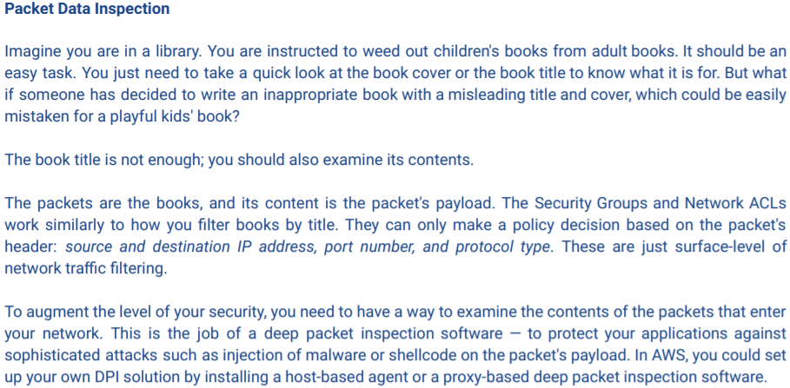

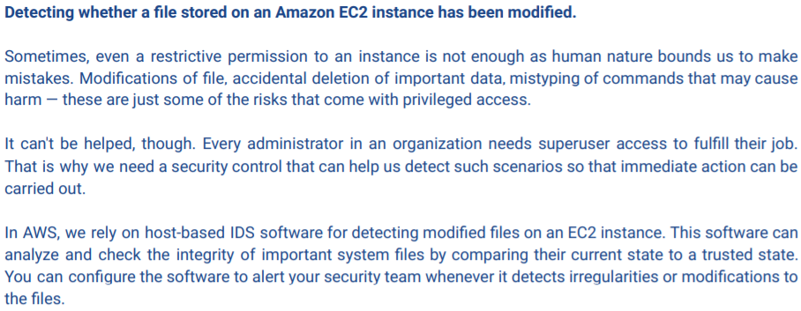

Disabling Source/Destination Check

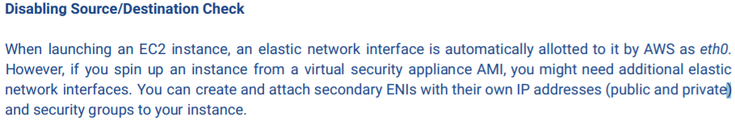

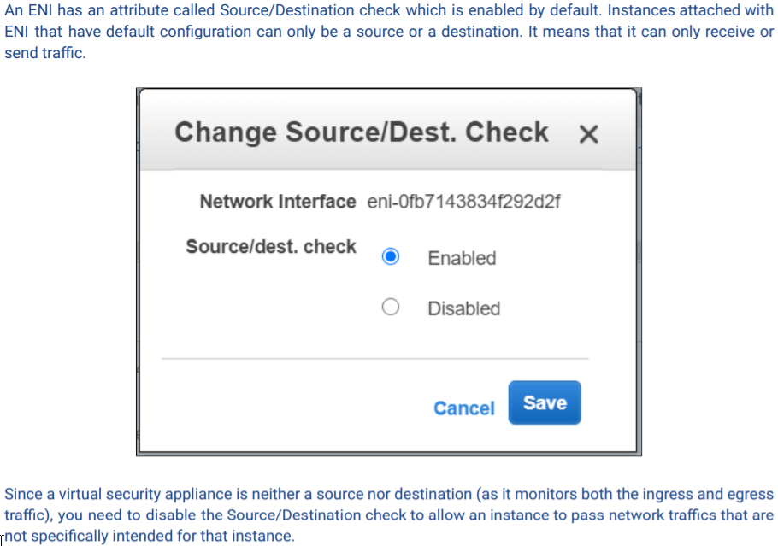

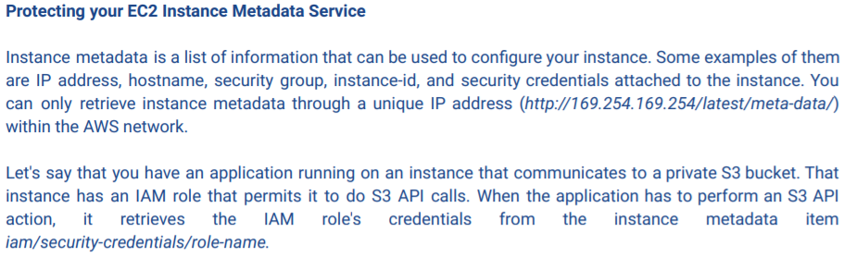

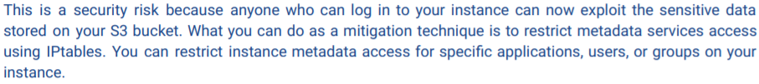

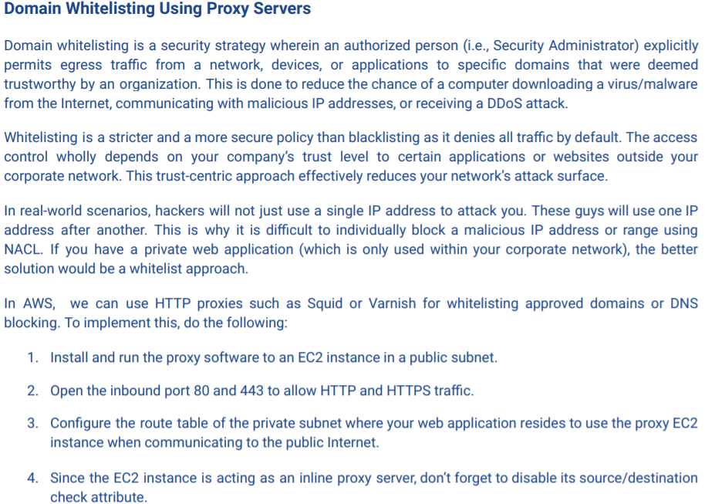

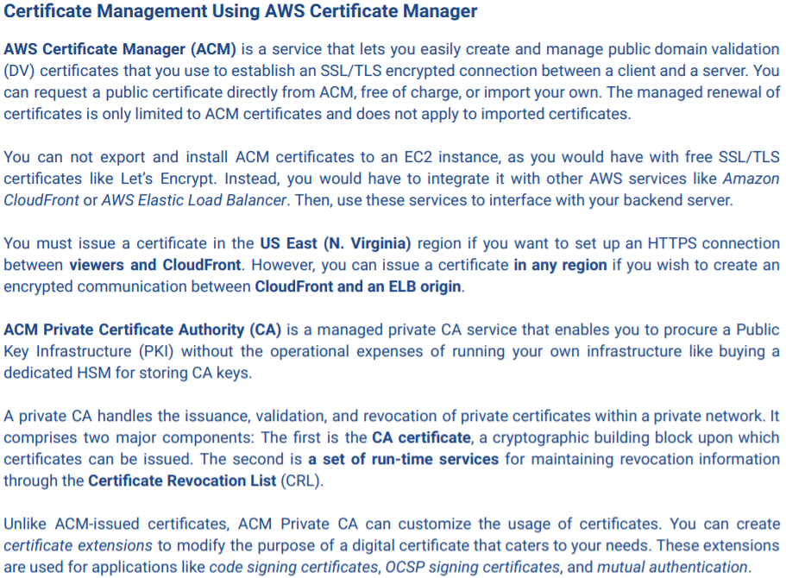

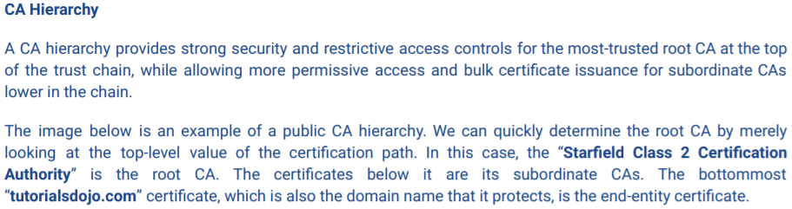

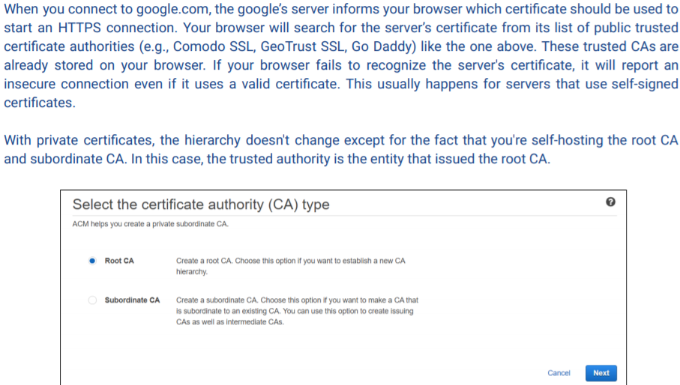 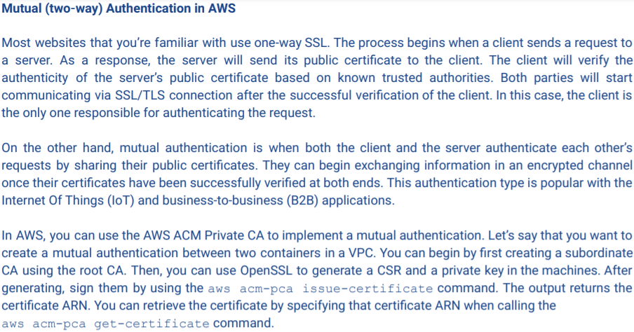

**ELB Security**

* **ALB** sits in between app and WAF which filters incoming requests from ALB
* **Subject Alternative Name (SAN)** allows you to issue a single SSL/TLS cert for different subdomains
* **SNI** – TLS protocol that lets you consolidate multiple certs to handle different domains in single location; domains served from single IP address – ALB’s endpoint to store multiple certs on single ALB to distribute
* **Perfect Forward Secrecy** – protocol that uses ephemeral key to encrypt data for each communication exchange; these keys are discarded once session ends; so even if attacker has managed to steal key used in a session, he can only decrypt data in transit that was encrypted by that key – reducing blast radius of breach; need to configure ELB to use Elliptic Curve Cryptography(ECDHE) to create shared ephemeral keys
* **Deregistering compromised EC2 instances**

1. Capture metadata from instance before making changes
2. Detach instance from ASG if it belongs to any then deregister compromised instance from target group
3. Change its security group rule to a more restrictive one allowing authorized users to access it

**DynamoDB Encryption**

1. Encryption Client – encryption at source & destination (E2E); only selected attribute values in an item encrypted – not table name, partition/sort keys; can be used w/encryption keys from KMS, CloudHSM
2. Server side at rest – all table data is encrypted

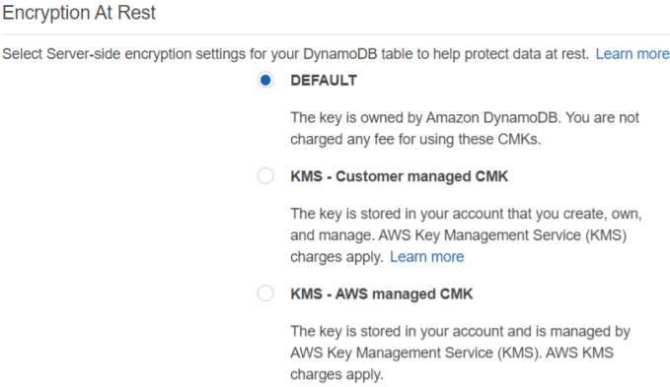

**Domain 4: IAM**

**Troubleshooting QuickSight and Athena connectivity**

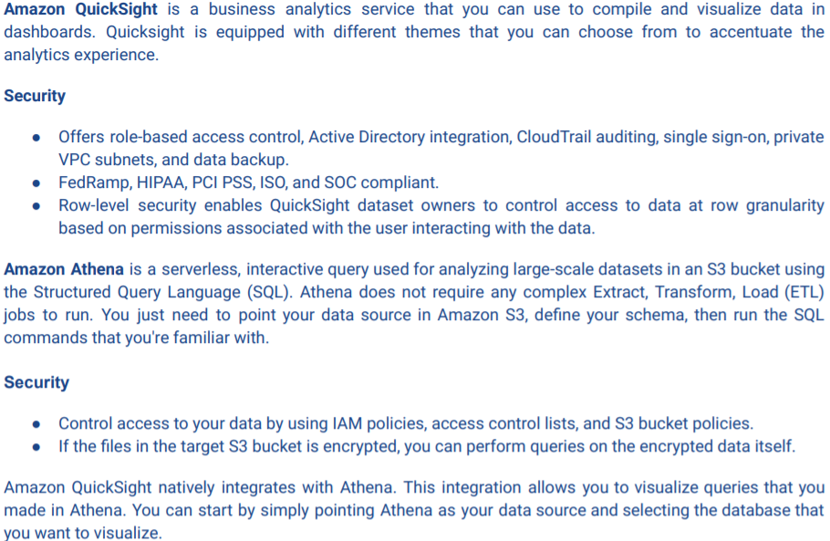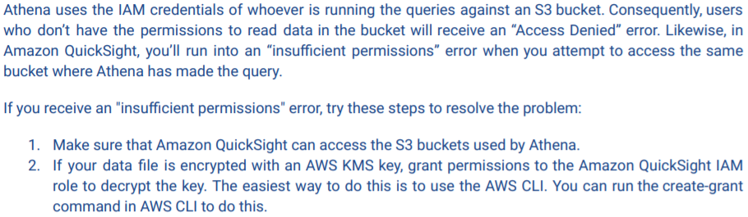

**IAM**

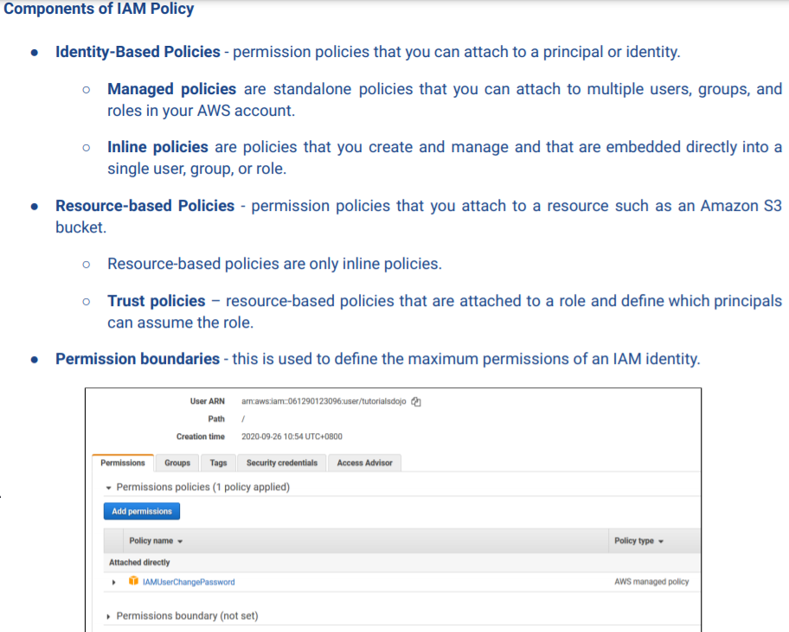

**Trust Relationships**

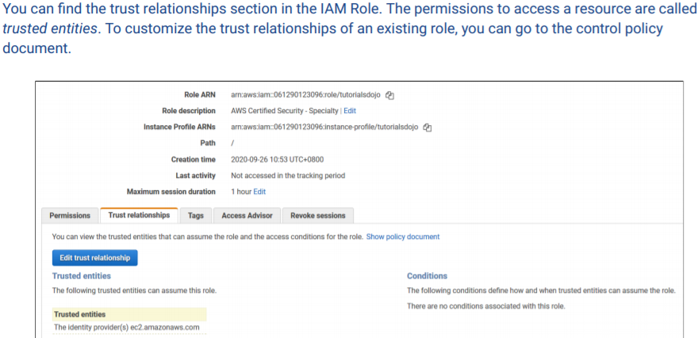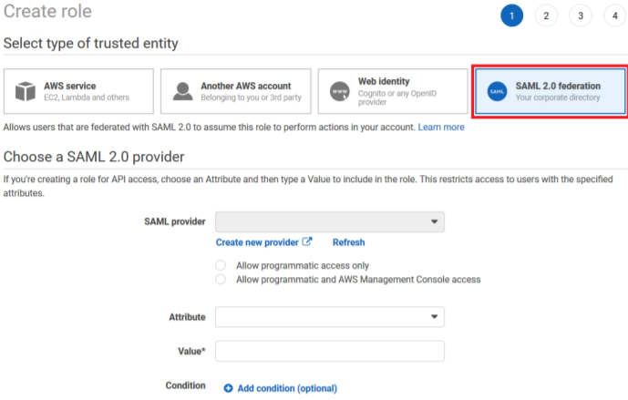

**Trusted Entity for the IAM Role**

1. AWS Service – grant a service to perform actions on your behalf (ie: Lambda, EC2)
2. Another Account
3. Web Identity – OIDC itentity providers: Amazon, Cognito, Facebook and Google
4. SAML 2.0 – users in corporate directory; role trust policy (who can assume the role) and IAM permissions policy (grants federated user actions to your resources)

IAM Identities – User, Role, Group, Identity Providers (IdP corporate directory of users)

Service-Linked Role – unique role directly linked to service; to delete role you must delete the related resource first

**Create IAM User instead of a Role**

1. You just created an AWS account and you’re the only person who will use that account
2. A group of individuals needs access to resources in your account but don’t have any existing credentials

**Create Role instead of IAM User**

1. You created an app hosted on EC2 instance and the app needs to make requests in other services
2. You created an app that runs on mobile device and needs to make a request to AWS
3. Users in org are already authenticated in corporate directory and want to use AWS w/o signing in again

Principal – entity that can request an action or operation on AWS resource (users, roles, federated users and apps)

Resource – object that exists w/in a service (S3, EC2 instances)

Policy evaluation starts w/an explicit deny; resource-based policies are evaluated before IAM-based policies

**Permissions Boundary** – doesn’t grant permission to IAM entity – only sets max permissions entity can have

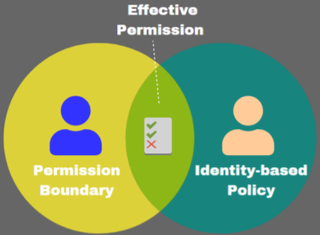

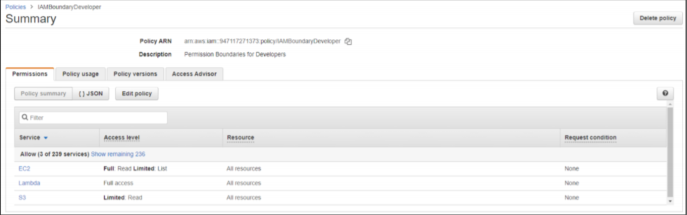 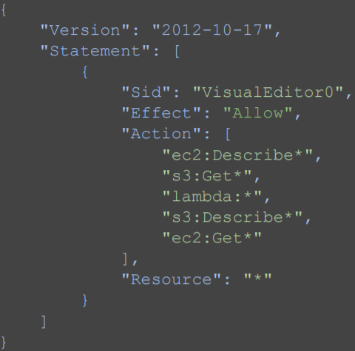

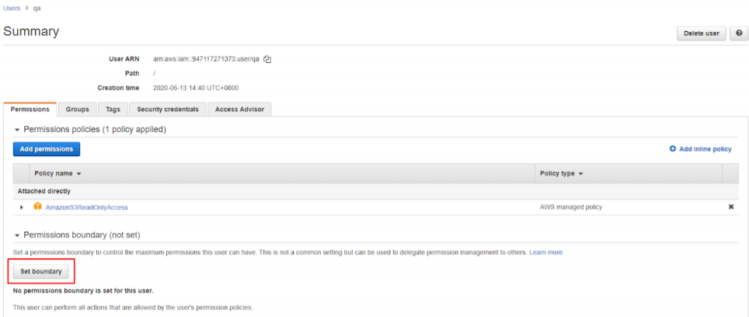

**Permissions Boundaries as Request Condition**

* Say a dev needs to create a role and policies for a Lambda. You give them access with a policy allowing them to do this but you don’t want them to create role policies with Admin Access. Instead you can create a Permission Boundary as a Request Condition (ie: IAMBoundaryDev). So on a separate permission add CreateRole and AttachRolePolicy and set Request Conditions for them. The condition requires any roles created/attached to have the IAMBoudaryDev permission boundary. So even if a role is created with an Admin Access policy it still has limited access from the permission boundary.

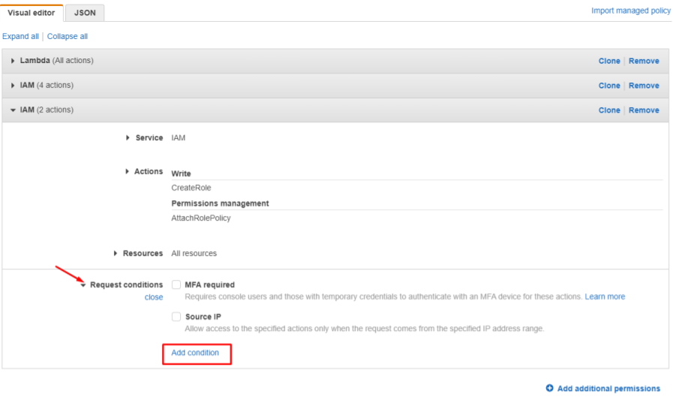 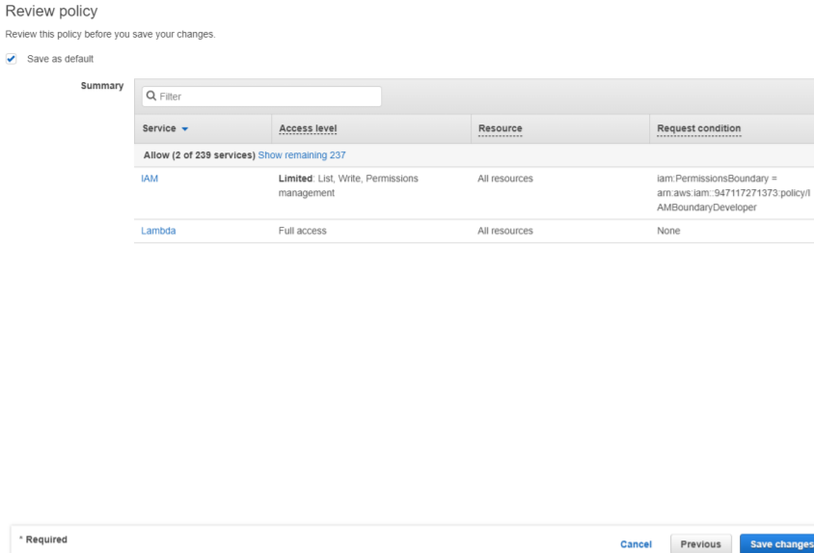

**PassRole**

* Permission that limits user to passing only approved roles
* A user needs to pass a role to an EC2 instance. To pass the role you must create these policies:

1. Permissions policy – what the role can do
2. Trust policy – who can assume the role

* PassRole will be accompanied by GetRole. The policy will allow the user to pass the role for the name that begins with ‘EC2-tutorialdojo-:’

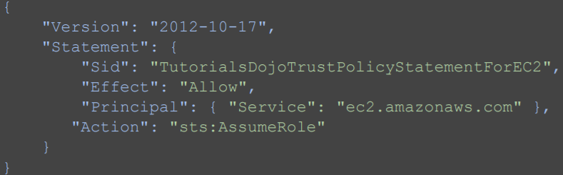 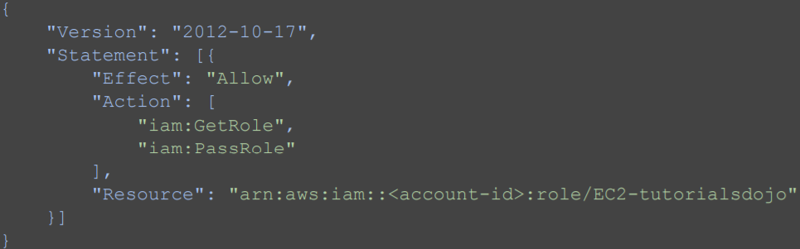

**Mapping Permissions of Active Directory User Attributes to Services**

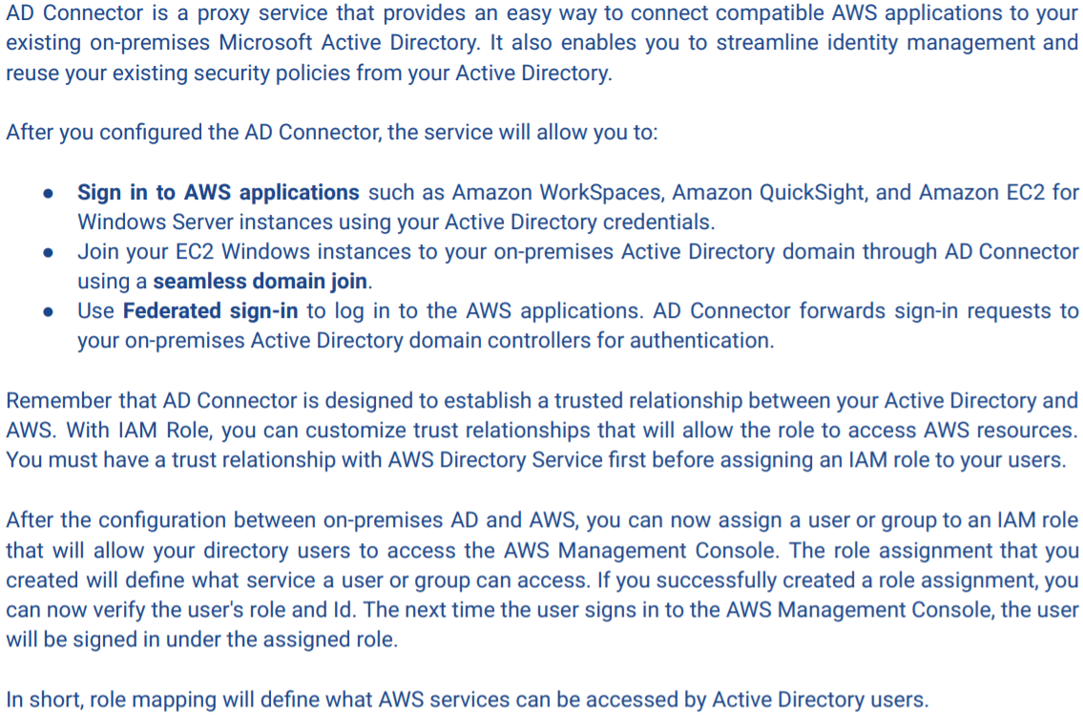 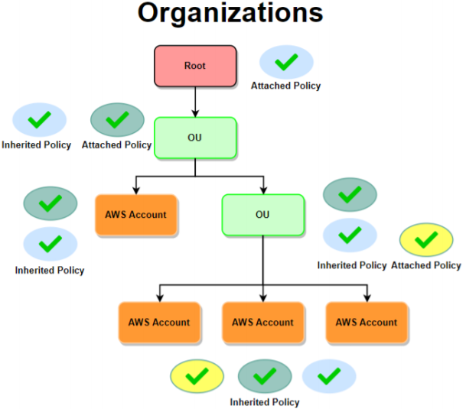

**AWS Organizations** to provide access to 3rd party AWS Accounts

* Benefit from consolidating billing and account management onto Master account - saves money

**Service Control Policies** to restrict permissions of root users in member accounts

* Only for (root) users/roles – do NOT affect resource roles directly; do NOT grant permissions – only max

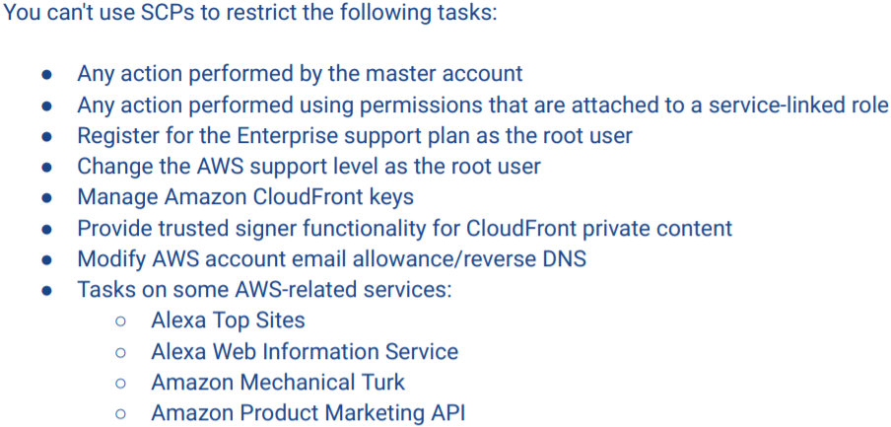

**Credential Reports for IAM**

* CSV file w/ user create date, ARN, last time key was rotated, last time password/access key used/changed
* Generated programmatically or via Console
* Automate disabling access key after x days – use Lambda to call GenerateCredentialReport, GetCredentialReport and UpdateAccessKey APIs

**Simple Token Service STS**

* Only accessible via API; all requests go to single endpoint – sts.amazonaws.com and logs recorded in CT
* NOTE: review pages more in depth

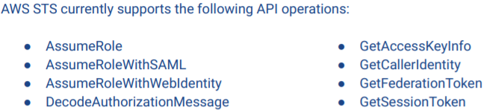

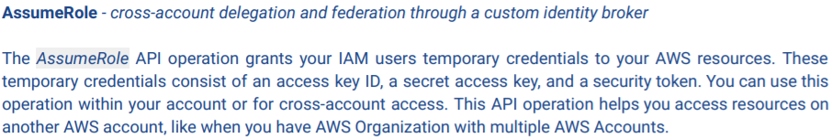

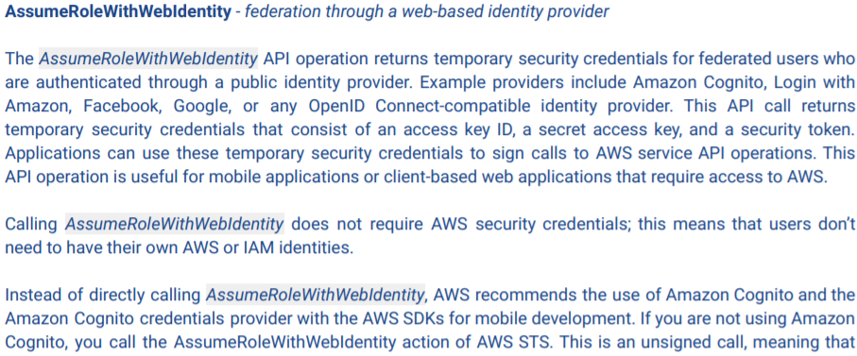

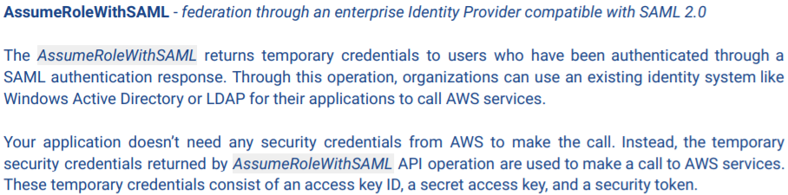

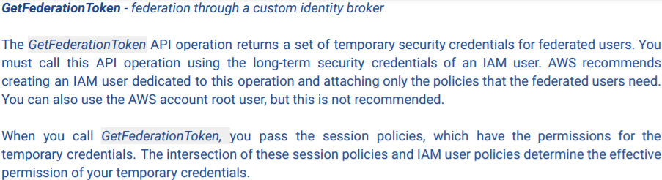

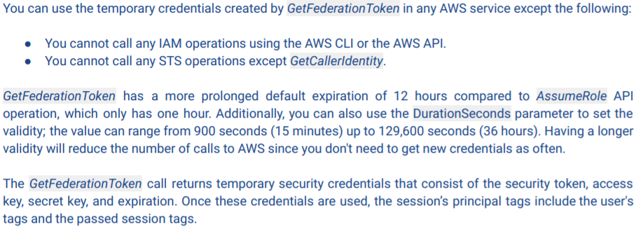

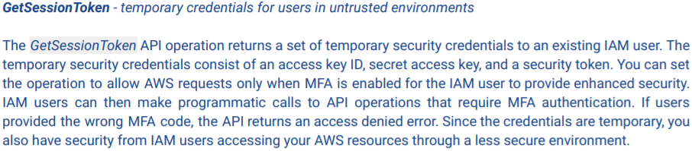

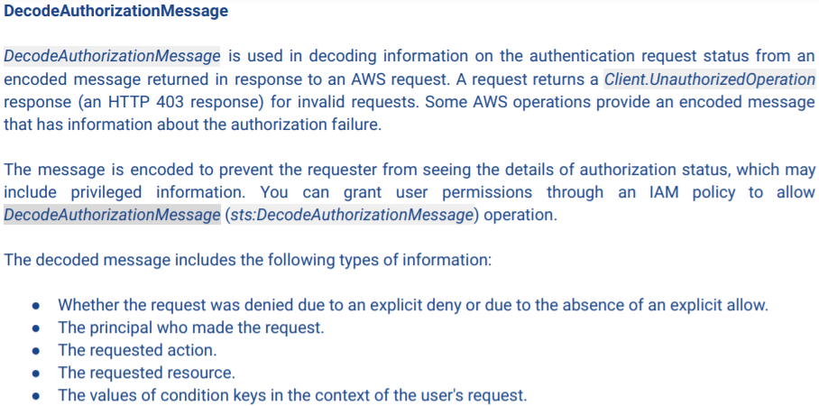

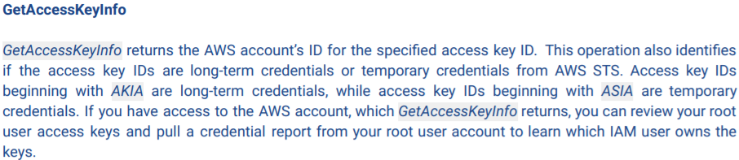

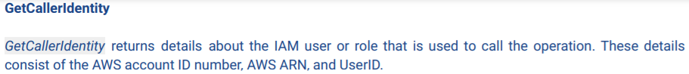

**Domain 5: Data Protection**

**Securing Data in CloudFront**

* PoPs (Edge use SSD and are faster) and REC (Regional less popular files use EBS are slower)
* These both are encrypted at rest
* 2 methods in deploying HTTPS connections in CF: Viewer and Origin Protocol Policy

1. **Viewer** – supports HTTP(s), Redirect HTTP to HTTPS and HTTPS Only
2. **Origin** – HTTP(s) and Match Viewer

* Origin server can be EC2 instance, ELB, MediaPackage, MediaStore, S3 bucket
* Origin Protocol Policy does NOT apply at S3 websites bc they only support HTTP
* Geo Restriction to deliver content to specific locations – black/whitelist countries

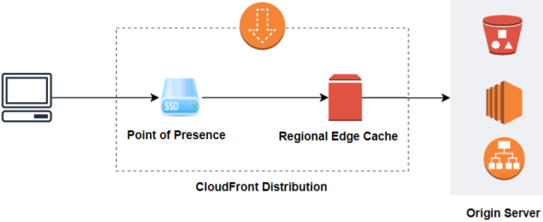 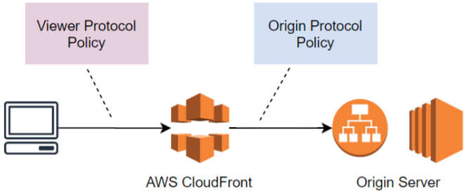

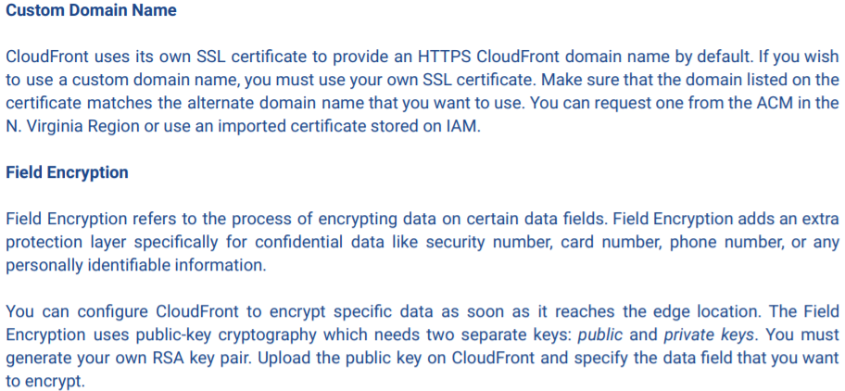 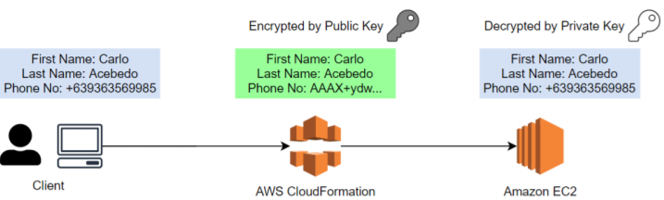

**ELB for encrypting traffic**

* ALB can only listen to HTTP(s) traffic; if you’re using a custom security protocol that requires a different port the consider using CLB or NLB

1. SSL Termination/Offloading

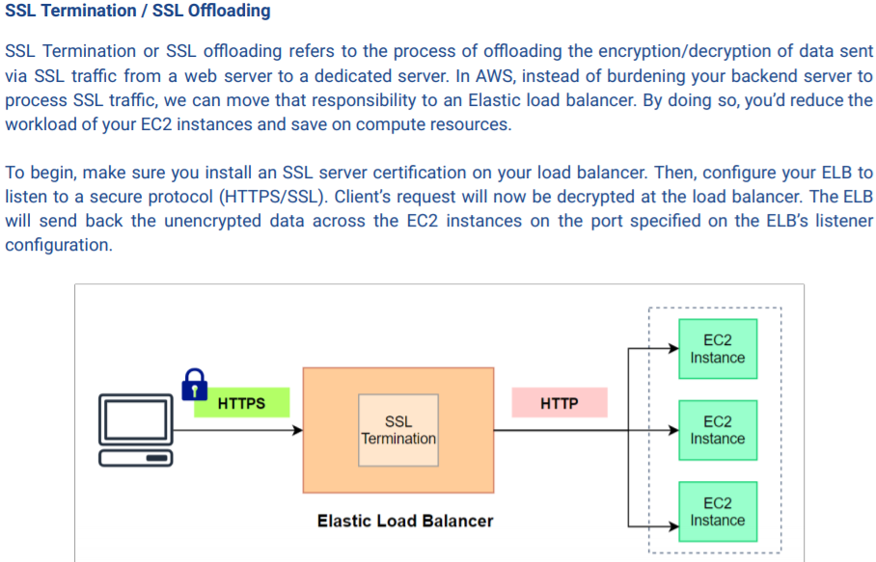

1. SSL Termination and Re-encryption

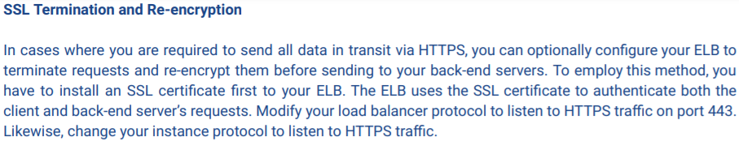

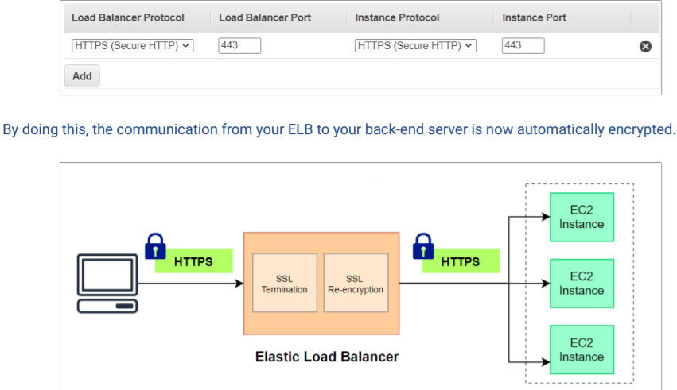

1. End-to-End Encryption

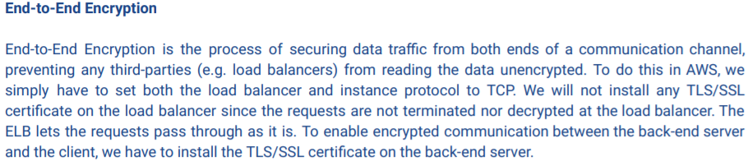

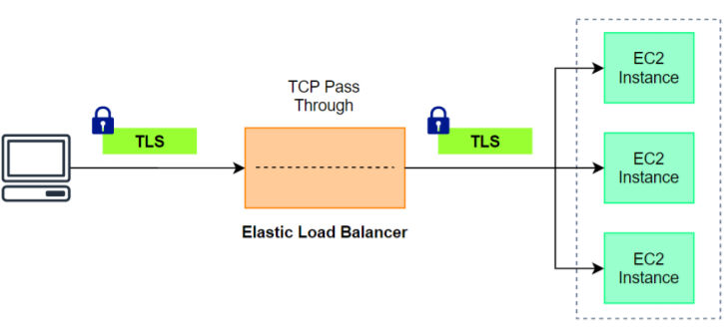

**Recover data of encrypted EBS volume if you lose CMK**

* EBS uses a data key derived from a CMK to encrypt data as it gets stored on disk

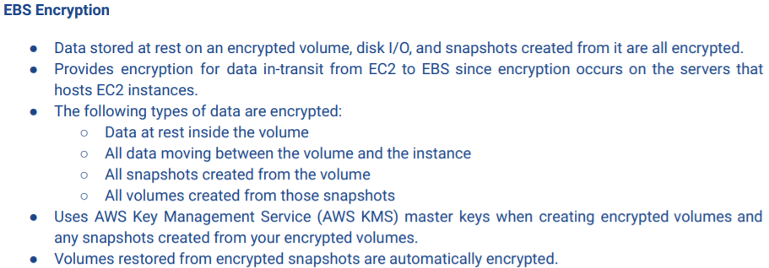 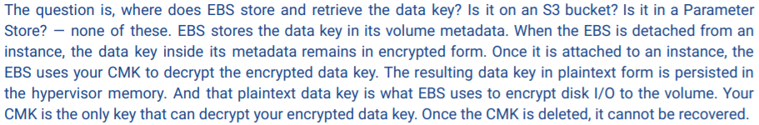

* To recover files from encrypted EBS volume, create a new EBS volume and mount it to the same instance where the encrypted EBS is attached. Then migrate the files from the old EBS to the new EBS

**Vault Locking in S3 Glacier**

* Vault – container for archived objects; can be created from Console but REQUIRED to interact w/via APIs
* Vault Lock – policy that specifies how your archives will be handled; WORM; once locked the policy can’t be changed
* One vault lock policy for each vault

**How to lock Glacier Vault using Glacier CLI**

1. Initiate the lock by attaching a vault lock policy to your vault. This command will set the lock to an in-progress state and return a lock ID. While in-progress you have 24 hrs to validate your vault lock policy.
2. Use the lock ID to complete the locking process







**Data Protection in Kinesis Data Analytics**

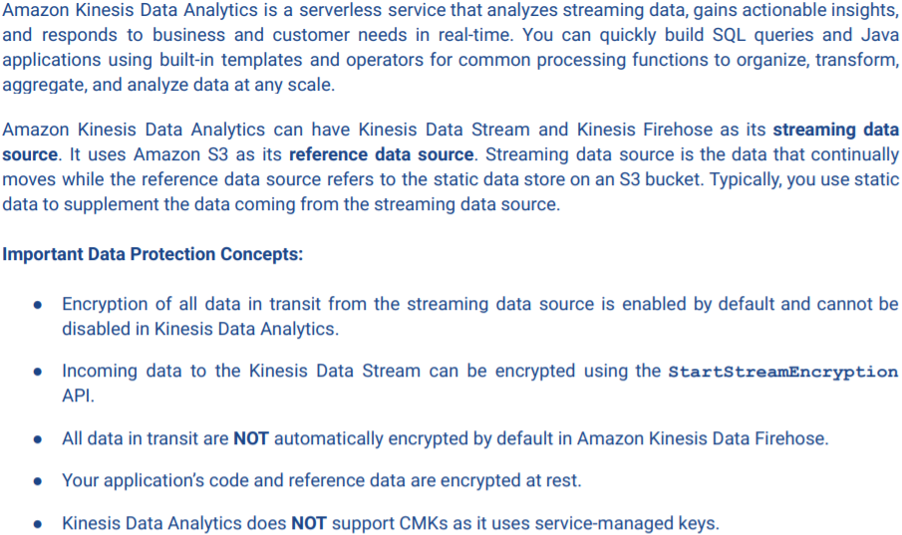

**Protecting S3 Bucket – VPC Endpoint and Encryption at rest/in transit**

* Not used w/in VPC; can’t use security groups/NACLs to control access
* VPC Endpoint – add gateway entry in VPC route table to pass through gateway instead of public internet

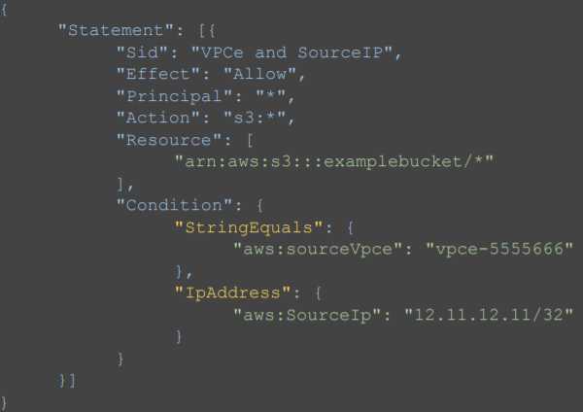 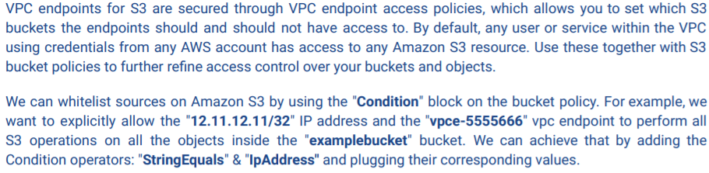

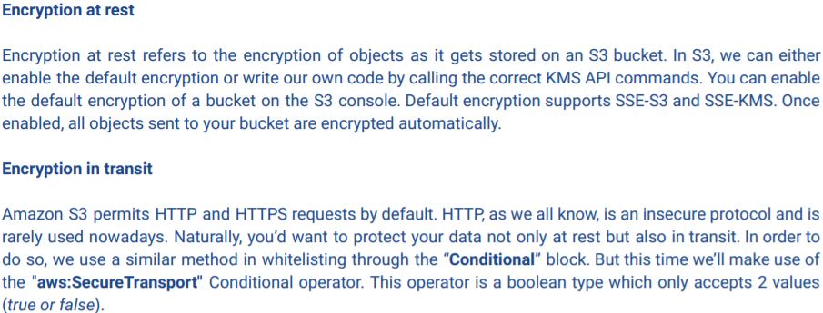 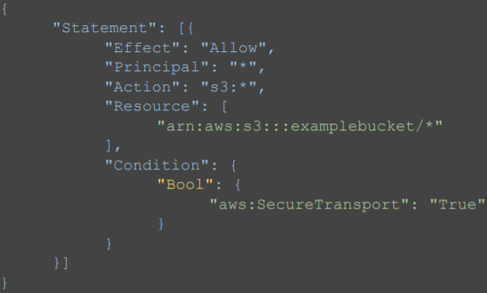

**S3 API Object-level logging**

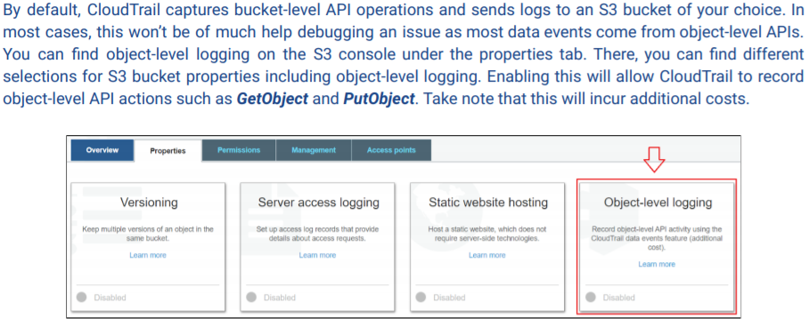

**Macie for Personally Identifiable Information PII**

